Integrating Common Core and Health Standards
Into Your Existing Lessons and Labs

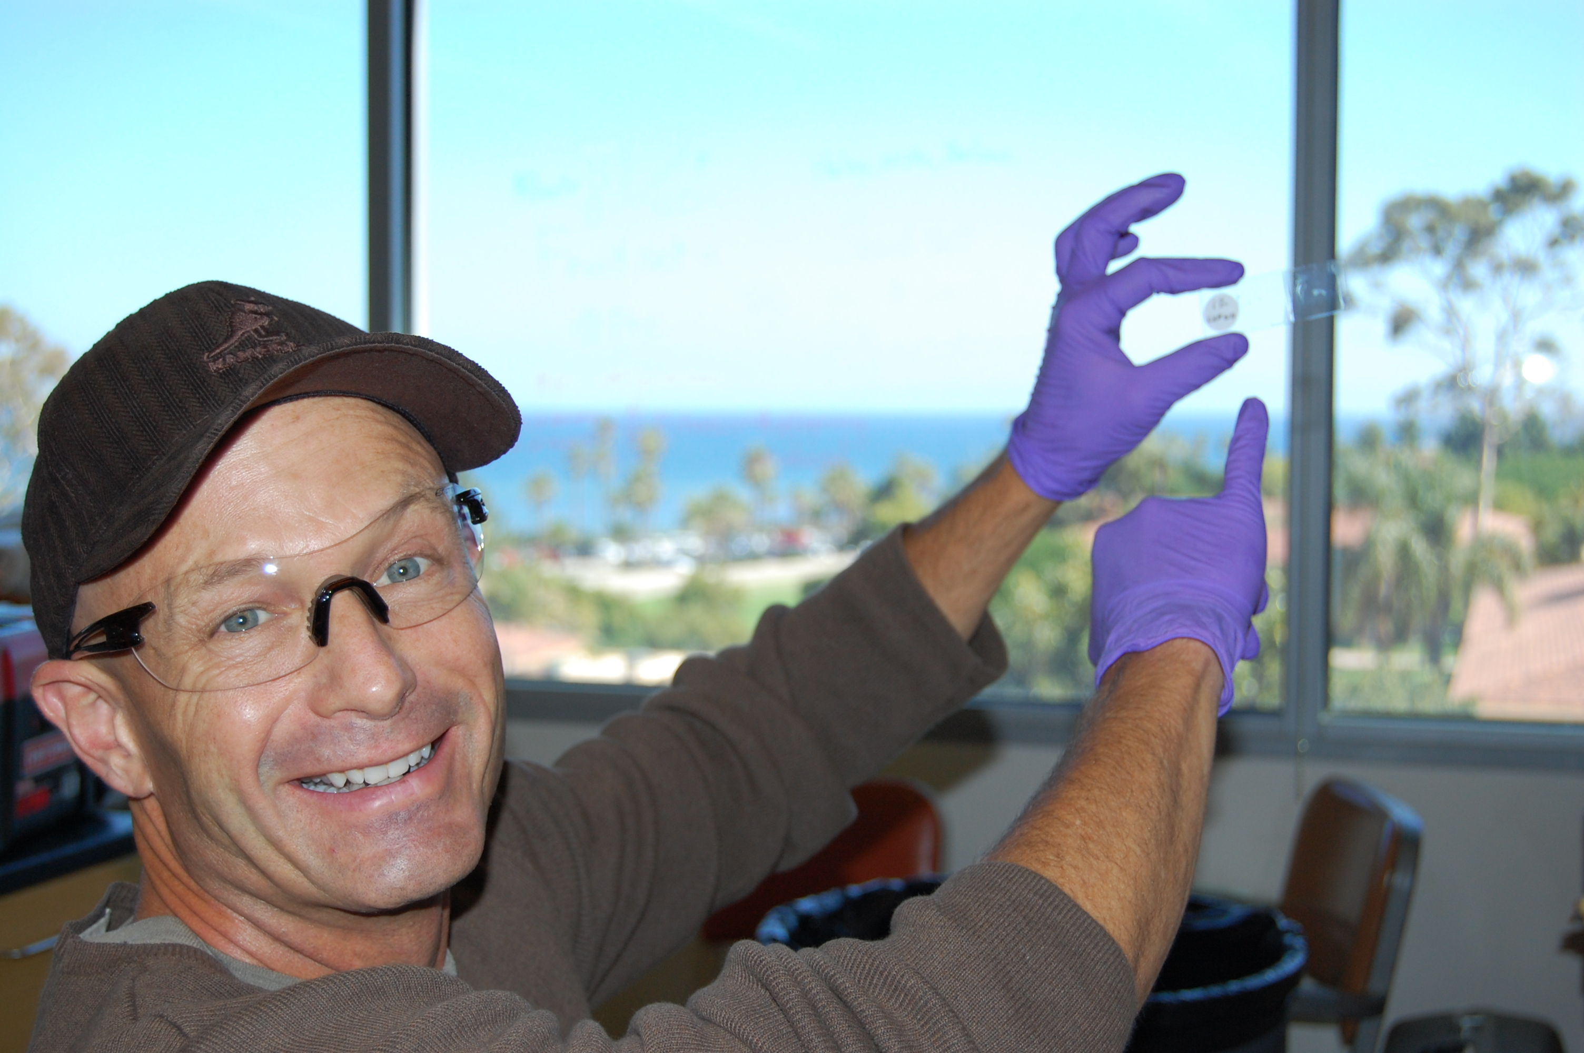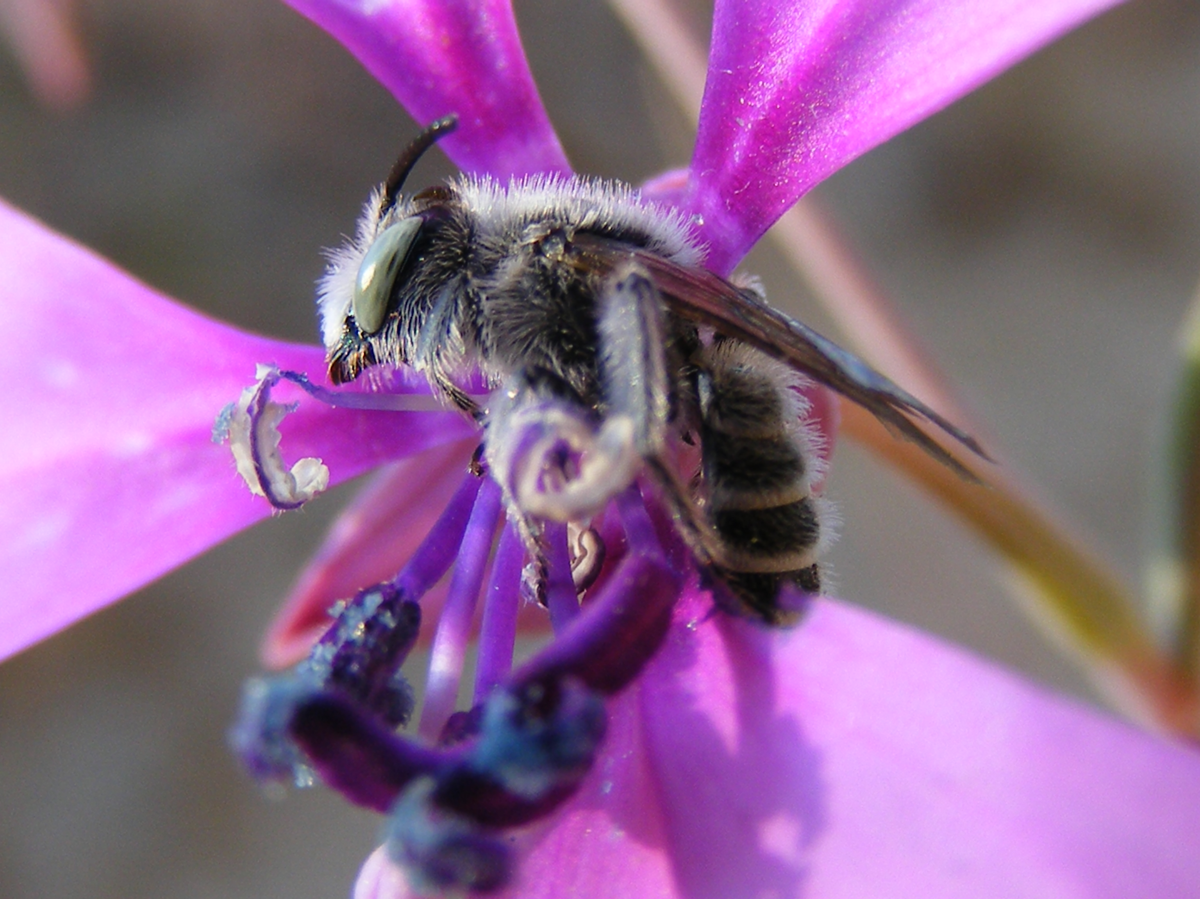

James Oliver Jackson, Jr
Goleta Valley Junior High
Goleta, Ca

UCSB RET ll

ABSTRACT

Two inquiry-based curriculum units are presented: “Flower Power” and “Don’t Blow it”. These lessons are easily adapted to cover a variety of State, Common Core and Health standards. The emphasis is health –a topic which is increasingly being incorporated into science. Both labs include community service and family involvement components.

Title: Integrating the New Common Core and Health Standards into your existing lessons and labs.

During RET I work with Alisa Hove in Dr. Susan Mazer’s Evolution and Ecology lab. We studied the evolution of mating systems in flowering plants, specifically the attrition rate of pollen tubes in Clarkia, a California wild flower.

Most flowering plants are hermaphroditic. Some are male first and release pollen before the stigma is receptive- (Protandry). Others are female first and the stigma is receptive before the pollen is released- (Protogyny):. In others the pollen is released at the same time the stigma is receptive. These flowers pollinate themselves. Dichogamy and herkogamy were also addressed in the research project. We call flowers that pollinate themselves “Selfers”. Flowers that receive pollen from other flowers are called “Outcrossers”.

The research I helped with showed that pollen tube attrition rates are higher in outcrossing taxa of Clarkia. This indicates greater competition between pollen from different sources and supports the idea of female mate choice in flowing plants. I was amazed that not unlike human female, the female flowers choose the genetic donor. I was inspired by my RET research to improve and expand my science and health units to make my labs more like the labs and experiments I observed at UCSB. I realized that my labs were more like instructions and less like the problem solving, brain storming, and inquiry I witnessed in the lab. Scientists synthesize new chemicals to communicate with human cells and deliver life saving drugs, make polymer photovoltaic cell to provide clean energy, all without instructions or specific procedures.

I present two units: “Flower Power” and “Don’t Blow it!” They are inquiry based. This will help students gain the skills needed for later university work. The labs are easily adapted to cover a variety of standards and topics. “Flower Power” takes a flower dissection to a whole other level by illustrating the hermaphroditic nature of flowers and natural selection in a changing environment. The assessment includes hypothesizing the function of flower structures and careful dissection and presentation of the flower.

In “Don’t Blow It!”, student build three apparatus to find vital capacity and tidal volume of the lungs. Student graph their data and self assess using the SULTAN graph rubric. The assessment piece models STAR release questions.

Both labs include a community service and family involvement component.

Both labs address the new State, Common Core, and Health standards.

