The Case of the Stolen Crystal
Unit Outline

Topic:
- Crystalline structure
- Crystal formation

Skills:
- Reading complex texts
- Creating a strong written argument
- Writing multi-step procedures
- Executing multi-step procedures

Subject/Grade Level:
- 8th grade Physical Science

Unit Overview:
- Day 1: Introduction to task and unit cell building
- Day 2: Guided reading of Kids Britannica Crystal article
- Day 3: Solving the mystery by interpreting data
- Day 4: Making and justifying the claim
- Day 5: Writing procedure for crystal growth
- Day 6: Regrowing the crystal

Inquiry Objective:
- Students will be able to identify the material that an unknown crystal is made of, and then grow a large, single crystal of that substance.

Learning Objectives:
- Students will be able to read an article and understand crystal formation, including how unit cell shapes relate to the shape of the macro-crystal.
- Students will be able to identify a crystal based on physical and chemical properties.
- Students will be able to explain the identity of an unknown crystal using appropriate and sufficient evidence.
- Students will be able to write a multi-step procedure to grow a large, single crystal from the powder form of a substance.
- Students will follow their written procedure and successfully grow a “replacement” crystal from the powder form of that substance.

Next Generation Middle School Physical Science Standards:
MS-PS1 Matter and Its Interactions
- MS-PS1. Develop models to describe the atomic composition of simple molecules and extended structures.
Science and Engineering Practices
- Develop a model to predict and/or describe phenomena.
- Develop a model to describe unobservable mechanisms.
- Analyze and interpret data to determine similarities and differences in findings.
- Undertake a design project, engaging in the design cycle, to construct and/or implement a solution that meets specific design criteria and constraints.
Disciplinary Core Ideas
- Each pure substance has characteristic physical and chemical properties (for any bulk quantity under given conditions) that can be used to identify it.
- Solids may be formed from molecules, or they may be extended structures with repeating subunits (e.g. crystals).
Crosscutting Concepts: Patterns
- Macroscopic patterns are related to the nature of microscopic and atomic-level structure.

Common Core State Standards:
Reading Standards for Literacy in Science and Technical Subjects 6-12
2. Determine the central ideas or conclusions of a text; provide and accurate summary of the text distinct from prior knowledge or opinions.
3. Follow precisely a multistep procedure when carrying out experiments, taking measurements, or performing technical tasks.
7. Integrate quantitative or technical information expressed in words in a text with a version of that information expressed visually (e.g. in a flowchart, diagram, model, graph, or table).
Writing Standards for Literacy in History/Social Sciences, Science, and Technical Subjects 6-12
- b. Support claims with logical reasoning and relevant, accurate data and evidence that demonstrate an understanding of the topic or text, using credible sources.
9. Draw evidence from informational texts to support analysis, reflection, and research.

Daily Plan: Day 1
Introduction to Task and Unit Cell Building

Daily Goal(s):
- Students understand that they will be responsible for growing a large, single crystal at the end of the unit.
- Students are primed for their independent reading article in Day 2.

Outline:
- Students read unit task and observe broken crystal.
- Students build 2 unit cells and all students combine unit cells to make a large crystal.
- Students reflect on crystal-building process.

Research:
According to Doug Buehl’s Developing Readers in the Academic Disciplines, particular instructional strategies need to precede the reading of complex disciplinary texts. Students with insufficient academic knowledge of the topic “are less likely to build that knowledge through reading assignments” (120). Teachers who expect students to advance their academic knowledge through reading assignments must ensure that students are primed for accessing the text.
Because students are required to read an Encyclopedia Britannica article and progress their understanding of crystal formation in Day 2, we spend Day 1 building knowledge and preparing the students for the reading. To build knowledge, students first observe the crystal and write down visible properties. This step asks students to focus on the macro-structure of a crystal. Next, students build a unit cell and assemble a crystal from those unit cells. This step allows students to see how the micro-structure determines the macro-structure of the crystal, a key point in the Day 2 reading. By spending Day 1 on building academic knowledge, we ensure that students are ready for complex academic reading on Day 2.

Materials:
- Large (5- 10g) crystals of alum
- Photocopied paper foldables (cube and hexagonal prism)
- Scissors, glue, colored pencils, and tape

Important Points:
- How to assemble the unit cell:
  - Color the atoms the appropriate color.
  - Cut out the foldable, making sure to leave the tabs.
  - Fold the foldable along all lines.
  - Apply glue to a tab and place tab on the inside of the adjacent face. Hold tab in place unit glue sets.
  - Repeat for all tabs. Tape may be useful for the last few tabs.
- How to assemble the crystal lattice from the unit cell:
  - Unit cells should be aligned so that each vertex has only one type of atom
  - There should be no empty spaces in the lattice
- Students should have an understanding of properties and be able to look at a substance and list physical properties.
- Misconceptions: There are a few misconceptions that may arise from this unit. The first is that students may begin to think of crystals as a series of “boxes” that are assembled, when really these “boxes” simply accentuate the shape of arrangement of atoms in a crystal. This should be emphasized.
- For teacher reference, there are pictures of each of the crystals below.

Epsom Salt | Table Salt | Alum
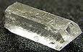 | 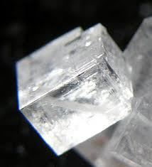

- It is possible to buy small crystals of fluorite, which are not made of any of the compounds above but do consistently have an octahedral shape. Teachers who do not want to prepare the large crystals themselves may consider buying these crystals on websites such as Etsy or Amazon.

Extensions:
For advanced students, consider giving them the hexagonal pyramid foldable and have students attach unit cells to form the crystal lattice. Though this unit cell is not found in nature, it still illustrates an important point not addressed: the macro-structure is not always the same shape as the micro-structure.

The Case of the Stolen Crystal
Day 1
Introduction to this Unit
Your little sister is awesome! Last week, she grew a crystal in the kitchen. She knows you really love crystals so she glued it to a hook, slipped it on a string, and gave you a crystal necklace for your birthday. You wore it all week and got tons of great compliments. However, on Friday you made her mad! So when you were sleeping, she snuck into your room and stole it back!
You begged and begged but she wouldn’t give you your crystal back! So you decided to take matters into your own hands: you are going to make that crystal yourself. The problem is that 1) you don’t know what the crystal is made of and 2) you don’t know how she grew the crystal. Your job for this unit is to figure out the composition of the crystal and how to regrow it.

Unit Timeline
Day 1: Build a Paper Crystal
Day 2: Read about Crystal Formation
Day 3: Determine Crystal Composition
Day 4: Prove It!
Day 5: Learn to Grow Crystals
Day 6: Regrow the Crystal

Observe the Crystal
Take your crystal and record the following.
Sketch the crystal. | List 3 properties of the crystal.

Frontloading: Making a Large Crystal from Unit Cells
Use the paper foldables to complete the worksheet.

Definitions:
Write the definitions given by your teacher.
macro- __________________________________________________________________
micro- __________________________________________________________________
unit cell- ________________________________________________________________
crystal lattice- ___________________________________________________________

Making a cell:
Make a model unit cell. First, color the atoms appropriately. Then cut, fold, and glue to assemble your three-dimensional structure. When your classmates have all made their unit cells, fit the unit cells together to make one, large crystal. This large crystal is called the crystal lattice. Repeat for second crystal.

In the table below, draw the unit cell and crystal lattice for each pattern.
 | Unit Cell (Micro-structure) | Crystal Lattice (Macro-structure)
Cube
Hexagonal Prism

Partner Reflection:
- Each paper foldable represents one unit cell. The crystal lattice is the shape of the overall crystal. Does the crystal lattice always have the same shape as the unit cell?
- Which direction does the crystal grow?
- Are there alternate ways to place the unit cells together? Explain if so.
The Case of the Stolen Crystal
Day 1
Introduction to this Unit
Your little sister is awesome! Last week, she grew a crystal in the kitchen. She knows you really love crystals so she glued it to a hook, slipped it on a string, and gave you a crystal necklace for your birthday. You wore it all week and got tons of great compliments. However, on Friday you made her mad! So when you were sleeping, she snuck into your room and stole it back!
You begged and begged but she wouldn’t give you your crystal back! So you decided to take matters into your own hands: you are going to make that crystal yourself. The problem is that 1) you don’t know what the crystal is made of and 2) you don’t know how she grew the crystal. Your job for this unit is to figure out the composition of the crystal and how to regrow it.

Unit Timeline
Day 1: Build a Paper Crystal
Day 2: Read about Crystal Formation
Day 3: Determine Crystal Composition
Day 4: Prove It!
Day 5: Learn to Grow Crystals
Day 6: Regrow the Crystal

Observe the Crystal
Take your crystal and record the following.
Sketch the crystal.  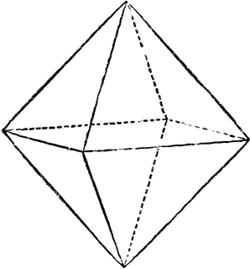 | List 3 properties of the crystal.  - clear  - solid at room temperature  - forms a regular solid

Frontloading: Making a Large Crystal from Unit Cells
Use the paper foldables to complete the worksheet.

Definitions:
macro- ___a prefix that means “large” or “overall”_______________________________
micro- ___a prefix that means “small”________________________________________
unit cell- _the smallest building block of a crystal; the repeating unit in a crystal_______
crystal lattice- _the overall shape or structure of a crystal_________________________

Making a cell:
Make a model unit cell. First, color the atoms appropriately. Then cut, fold, and glue to assemble your three-dimensional structure. When your classmates have all made their unit cells, fit the unit cells together to make one, large crystal. Repeat for second crystal.

In the table below, draw the unit cell and crystal lattice for each pattern.
 | Unit Cell (Micro-structure) | Crystal Lattice (Macro-structure)
Cube | 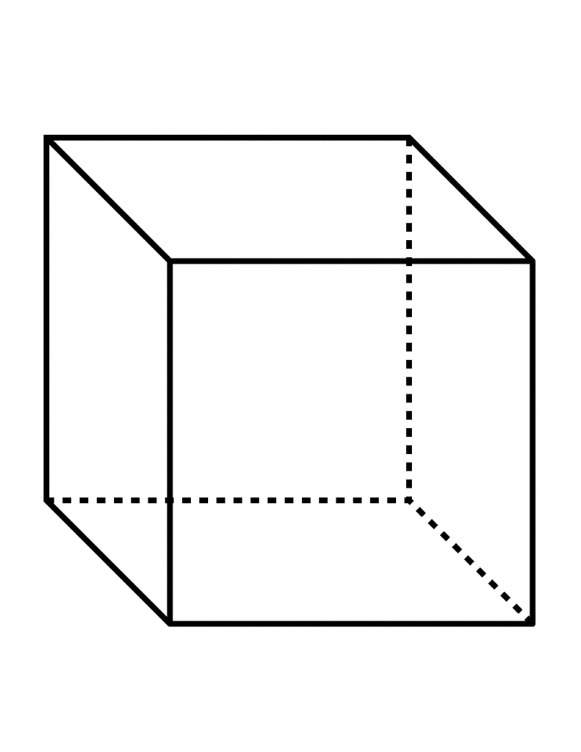
Hexagonal Prism | 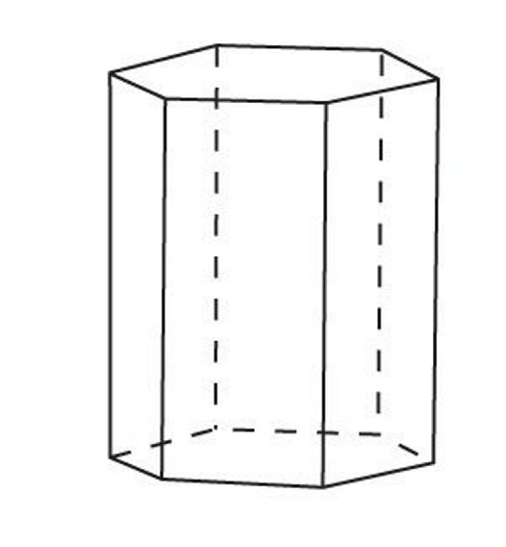 | 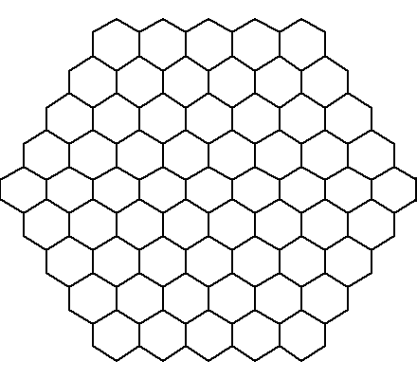

Partner Reflection:
- Each paper foldable represents one unit cell. The crystal lattice is the shape of the overall crystal. Does the crystal lattice always have the same shape as the unit cell?
- Which direction does the crystal grow?
- Are there alternate ways to place the unit cells together? Explain if so.
Paper Foldable: Hexagonal Prism

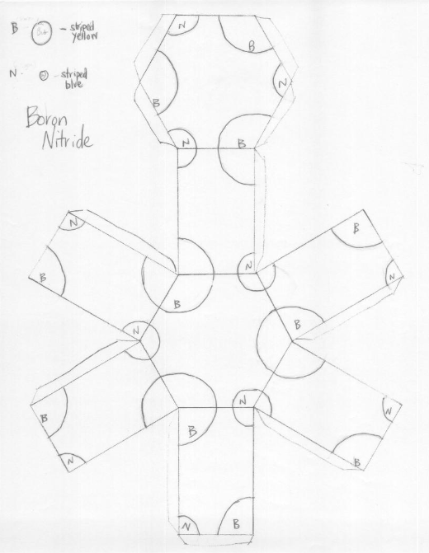
Paper Foldable: Cube

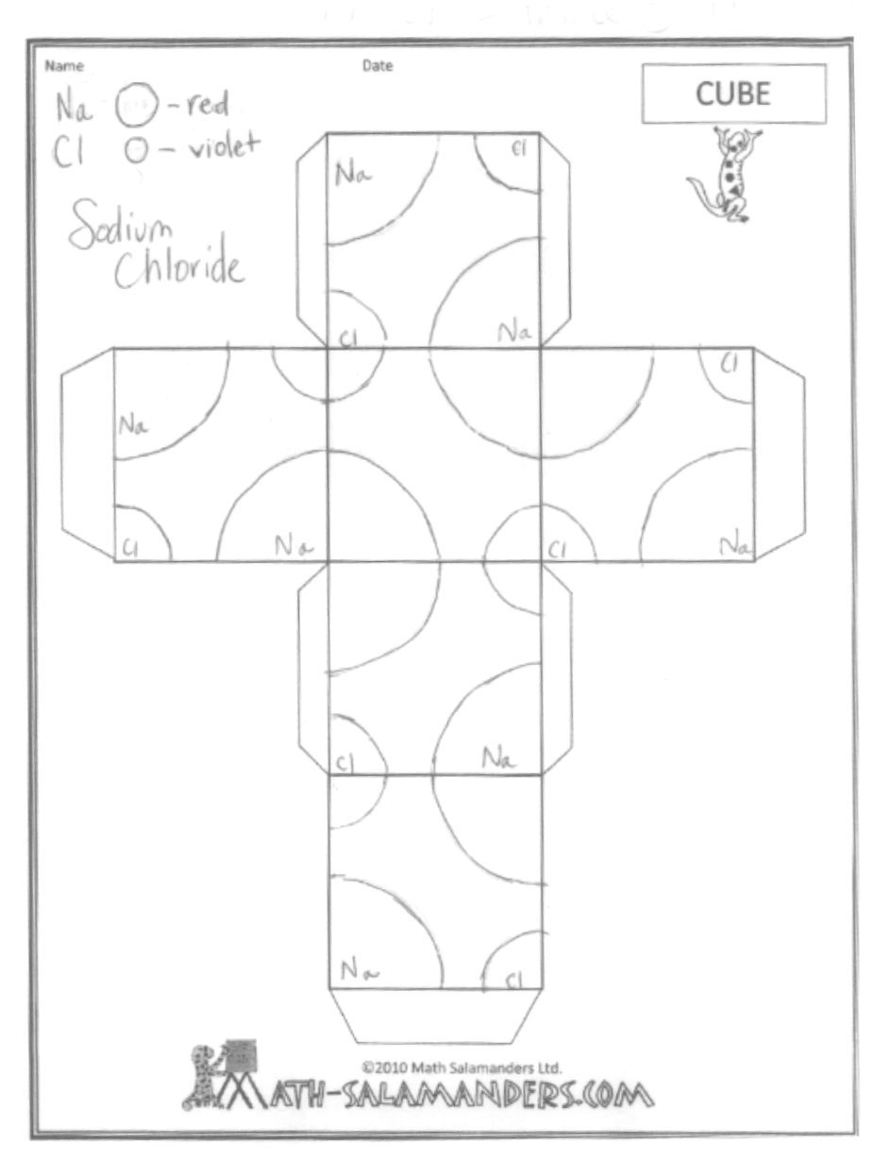
Paper Foldable: Hexagonal Pyramid

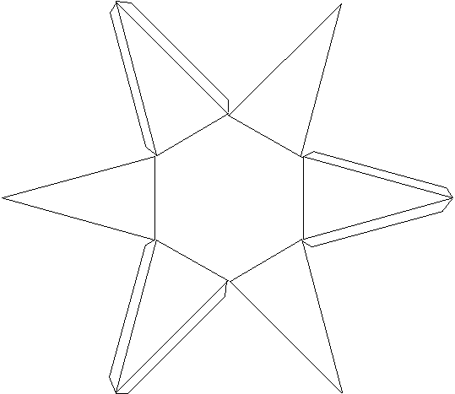

Daily Plan: Day 2
Guided Reading of Kids Britannica Crystal Article

Daily Goal(s):
- Students read first 5 paragraphs of their article and articulate their understanding by completing the Guided Reading worksheet.
- Students understand that there are 7 categories of unit cells, and each type of unit cell can form a variety of macro-structures.

Outline:
- Students read Kids Britannica article and examine crystal structure chart.
- Students use the article and chart to complete a guided reading exercise.

Research:
Doug Buehl’s Developing Readers in Academic Disciplines outlines how to guide thinking through Interactive Reading Guides. For complex texts, these guides can be crucial, as the thinking required “will be challenging for many students to tackle independently … given the complexity of a specific text”(252). These guides ask students to work together, and the guides provide a scaffold to work a complete text. By completing these guides, students are learning the metacognitive processes that occur during complex reading tasks; they require students to “slow down” and genuinely engage with each part of the text.

Materials:
- Photocopy of Kids Britannica Crystals article (first 5 paragraphs are all that is absolutely necessary)
- Photocopy of Crystal Shapes handout

Important Points:
- Make sure to collect the articles for use in Day 5.
Day 2
Guided Reading
Consider the article at http://kids.britannica.com/comptons/article-9273872/crystals . For this assignment, you are only using the first 5 paragraphs. How might this article help you with the task at hand? Briefly discuss with your neighbor, and then work with your neighbor to complete the task at hand.
Part 1- Read each of the paragraphs and write a sentence explaining what each paragraph is about.  1 ________________________________  ________________________________  2 ________________________________  ________________________________  3 ________________________________  ________________________________  4 ________________________________  ________________________________  5 ________________________________  ________________________________ | Part 3- Underline the 3 sentences that discuss single crystals. Rephrase those sentences so that it is clear that you understand what they mean.
Part 2- Using the correct paragraph found above, graphically explain the connection between molecules and the crystal lattice.

molecules

crystal lattice
Part 4- Look at the attached chart “Crystal Shapes”

List the 7 categories of unit cells:
1 __________________________
2 __________________________
3 __________________________
4 __________________________
5 __________________________
6 __________________________
7 __________________________

Write down and sketch any 2 crystal shapes:

&

Write down the name of the unit cell that you made yesterday:

Using the Crystal Shape paper, list each unit cell shape. Then, for each shape, list the possible macro-structures.

- _______________________
- _______________________________
- _______________________________
- _______________________________
- _______________________________
- _______________________________
- _______________________________

- _______________________
- _______________________________
- _______________________________
- _______________________________
- _______________________________
- _______________________________

- _______________________
- _______________________________
- _______________________________

- Triclinic
na

- _______________________
- _______________________________
- _______________________________
- _______________________________

- _______________________
- _______________________________
- _______________________________
- _______________________________

- _______________________
- _______________________________
- _______________________________
- _______________________________

Day 2
Guided Reading
Consider the article at http://kids.britannica.com/comptons/article-9273872/crystals . For this assignment, you are only using the first 5 paragraphs. How might this article help you with the task at hand? Briefly discuss with your neighbor.
Part 1- Read each of the paragraphs and write a sentence explaining what each paragraph is about.  1 __A crystal is a solid with regularly____ arranged surfaces. ________________  2 The arrangement of the atoms______ determines the shape of the unit cell and the shape of the larger crystal. _______  3 __Solids can either be crystalline, ____ amorphous, or mixed._______________  4 ____Liquid crystals share properties of both liquids and crystals._____________  5 __In a large single crystal, the shape of the crystal reflects the structure of the__ unit cell.__________________________ | Part 3- Underline the 3 sentences that discuss single crystals. Rephrase those sentences so that it is clear that you understand what they mean.  Occasionally, a crystal will form that has all of the unit cells arranged in the same orientation. When this happens, there is a single crystal, and the shape of that single crystal reflects the shape of the unit cell.
Part 2- Using the correct paragraph found above, graphically explain the connection between molecules and the crystal lattice.

molecules

unit cells

crystal lattice
Part 4- Look at the attached chart “Crystal form of the seven crystal systems.”

List the 7 categories of unit cells:
1 ____cubic______________
2 ____tetragonal__________
3 ____orthorhombic_______
4 ____monoclinic_________
5 ____triclinic____________
6 ____hexagonal__________
7 ____trigonal____________

Write down and sketch any 2 crystal shapes:
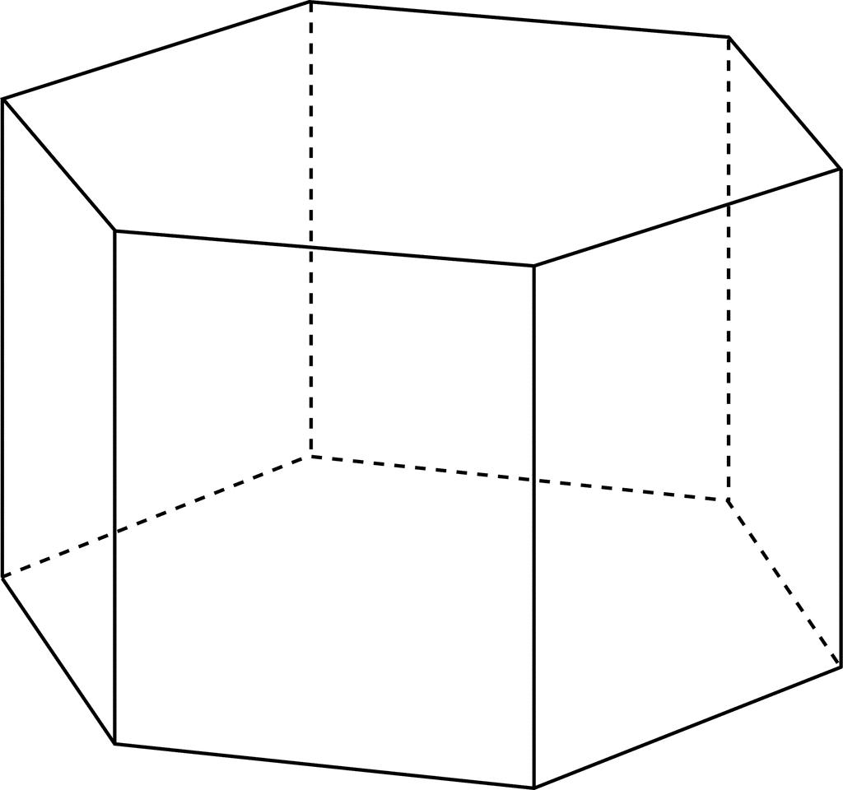 & 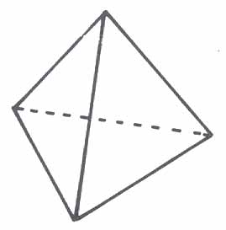
hexagonal prism tetrahedron
Write down the name of the unit cells that you made yesterday: cube and hexagonal prism

Using the Crystal Shape paper, list each unit cell shape. Then, for each shape, list the possible macro-structures.

- Cubic
a. cube
b. octahedron
- dodecahedron
- tetrahedron
- pyritohedron
- cube and pyritohedron

- Orthorhombic
a. pinacoids
b. prism and basal pinacoids
c. pyramid
- orthorhombic sphenoid and prism
- prism, domes, and two pinacoids

- Monoclinic
a. domes and pinacoid
b. prism and pinacoid

- Triclinic
na

- Trigonal
a. rhombehedra
b. trigonal trapezohedrom
c. trigonal scalenohedron

- Hexagonal
a. hexagonal prism and base
b. hexagonal pyramid
c. hexagonal prism and pyramid

- Tetragonal
- tetragonal and ditetragonal prism and base
- tetragonal pyramid
- prism and pyramid

Crystal Shapes
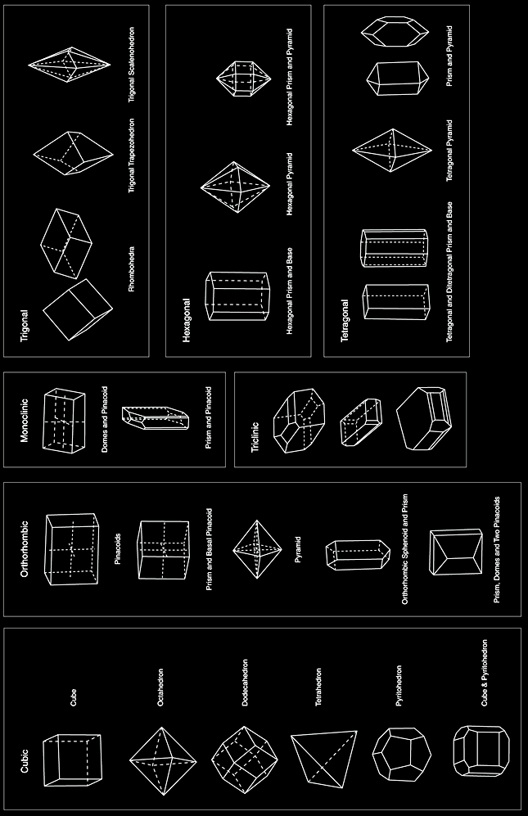
Daily Plan: Day 3
Solving the Mystery by Interpreting Data

Daily Goal(s):
- Students use the information in the data table to determine the identity of the crystal.
- Students begin to show proof for and elaborate upon their claim.

Outline:
- Students examine the data table.
2. Students discuss the identity of the crystal.
- Students interpret the table using the guiding questions.

Research:
In their book Supporting Grade 5-8 Students in Constructing Explanations in Science, Katherine McNeill and Joseph Krajcik extensively discuss the Claim-Evidence-Reasoning (CER) format of constructing explanations in science. In order to use the CER format, a teacher must identify possible learning tasks for students to engage in that allow the CER format to be used. According to McNeill and Krajcik, those opportunities must include 3 features: 1) students must be constructing a scientific claim, 2) there must be data to analyze, and 3) students must be using or developing scientific principles(46-7).
In the Day 3 learning task, we are asking students to focus on “finding the answer” or identifying the compound that their stolen crystal is made of. Essentially, we are asking them to focus on features 2 and 3 listed above: analyzing data and applying scientific principles. Students need to use the data provided and their knowledge of crystals to identify alum as the correct compound. In Day 4, students will focus on feature 1: writing the claim based on features 2 and 3.

Materials:
- 5-10 g alum single alum crystal for students to examine

Day 3
Reading the Labels
You read the labels of the container and organized the data in the chart below.

Substance  Name | Solubility  at 20 °C | Crystal  Color | Crystalline Micro-structure | Crystalline Macro-structure
Epsom Salt | 71 g/100 mL | Clear | Monoclinic | sphenoid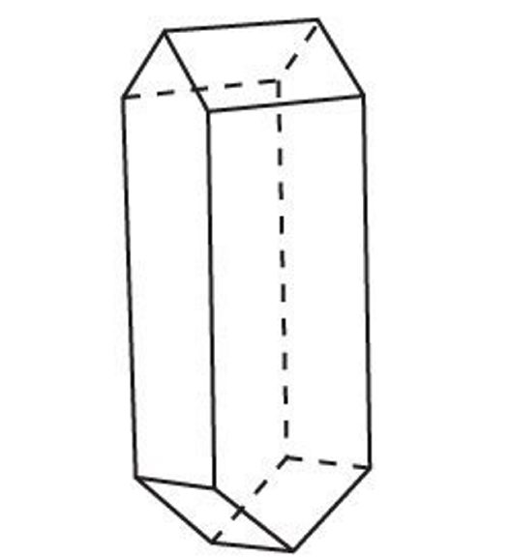
Table Salt | 35.7 g/100 mL | Clear | Cubic | Cube  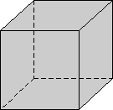
Alum | 14.0 g/100 mL | Clear | Cubic | Octahedron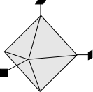

Interpreting the Table
Briefly discuss with your neighbor which substances your crystal could be made of. Feel free to mark the chart as you discuss. Then answer the questions below.

- Is there enough information in the chart above to identify what your crystal is made of? If so, state the identity of your crystal. ___________________________________________________
_______________________________________________________________________________

- Are you completely sure of the identity of your crystal? Is there any way that you could be mistaken? ______________________________________________________________________
_______________________________________________________________________________

- Explain what data in the chart you used to identify your crystal. ___________________________ _______________________________________________________________________________

- Is there any data that you did not use to identify your crystal? ____________________________
_______________________________________________________________________________

- Based on the data above, explain how you know what your crystal is made of. _______________ _______________________________________________________________________________ _______________________________________________________________________________ _______________________________________________________________________________ _______________________________________________________________________________

Day 3
Reading the Labels
You read the labels of the container and organized the data in the chart below.

Substance  Name | Solubility  at 20 °C | Crystal  Color | Crystalline Micro-structure | Crystalline Macro-structure
Epsom Salt | 71 g/100 mL | Clear | Monoclinic | sphenoid
Table Salt | 35.7 g/100 mL | Clear | Cubic | Cube
Alum | 14.0 g/100 mL | Clear | Cubic | Octahedron

Interpreting the Table
Briefly discuss with your neighbor which substances your crystal could be made of. Feel free to mark the chart as you discuss. Then answer the questions below.

- Is there enough information in the chart above to identify what your crystal is made of? If so, state the identity of your crystal. __There is enough information in the chart above to identify our crystal. Our crystal is composed of alum.________________________________________

- Are you completely sure of the identity of your crystal? Is there any way that you could be mistaken? ___I suppose it is possible that we are mistaken but based on the evidence we have, the crystal appears to be alum.____________________________________________________

- Explain what data in the chart you used to identify your crystal. __The crystal we were given has a clear octahedral shape. The only substance that forms an octahedral crystal is alum. _______

- Is there any data that you did not use to identify your crystal? __ Yes. We did not need to use solubility or crystal color. However, it would strengthen our argument if we could use that data. _____________________________________________________________________________

- Based on the data above, explain how you know what your crystal is made of. ___I know that our crystal is made of alum and not Table salt or Epsom salt. The sample crystal has an octahedral macro-structure, and neither Epsom salt nor Table salt exhibits this structure; only alum forms an octahedral single crystal. _________________________________________________________
_______________________________________________________________________________
Daily Plan: Day 4
Making and Justifying the Claim

Daily Goal(s):
- Students write a formal scientific explanation explaining the identity of their crystal.

Outline:
- Students work with their partner to establish and write each section of the explanation.

Research:
In their book Supporting Grade 5-8 Students in Constructing Explanations in Science, Katherine McNeill and Joseph Krajcik relay an anecdote of a middle school student who was asked to write a scientific explanation detailing if two substances were the same or different. Although provided with data, the student, “Brandon,” used none of it to support his claim. Instead, he used he used everyday knowledge and faulty reasoning to justify his claim. Although his claim was correct, his justification was insuffifient, and he needed support in constructing explanations.
Brandon’s teacher, recognizing the need for training students to construct explanations, implemented a lesson that supported students in the CER format. Students, including Brandon, markedly improved, citing the data provided and also using scientific content knowledge to substantiate their claim.
Assuming that most students are similar to Brandon and his classmates, it is apparent that students need support in contructing these explanations. The CER format reminds students of the key components in an explanation: their claim, evidence (or data) supporting that claim, and the reasoning or explanation for why that data proves their claim. This Day 4 lesson supports students in constructing their explanations using the CER format.

Materials:
- Completed Worksheets from Day 3

Day 4
Formal Claim
In the space below, explain which substance the crystal is made of, and how you know. Make sure to use the claim-evidence-reasoning format to fully support your claim.

The crystal is made of …____________________________________________________ ________________________________________________________________________The data table above shows that …___________________________________________ ________________________________________________________________________________________________________________________________________________________________________________________________________________________________________________________________________________________________Because …_______________________________________________________________ ____________,___________________________________________________________________________________________________________________________________________________________________________________________________________________________________________________________________________________________________________________________________________________________________________________________________________________________________________________________________________________________________________________________________________________________________________________________________________________________________________________________________________________________________________________________________________________________________________________________________________________________________________________________________________________________________________________________________________________________________________________________________________________________________________________________________________________________________________________________________________________________________________________
Day 4
Formal Claim
In the space below, explain which substance the crystal is made of, and how you know. Make sure to use the claim-evidence-reasoning format to fully support your claim.

The crystal is made of …_alum_______________________________________________ ________________________________________________________________________The data table above shows that …_any single crystal of alum will form an octahedron. A single crystal of Epsom salt will be sphenoidal, and a single crystal of Table salt will be cubic. The crystal my sister gave me is octahedral.___________________________ ________________________________________________________________________________________________________________________________________________Because … the sample is octahedral, and Epsom salt and Table salt do not form_______ octahedral crystals, the sample cannot be Epsom or Table salt. Alum, however, does form octahedral crystals, so the sample could be alum. As long as these 3 substances are our only options, the crystal must be a crystal of alum.________________________
If we were to investigate this further, we could investigate the other properties:_______ solubility, crystal color, density, melting point, and pH. If these properties of our mystery crystal matched those of alum listed above, we would have even stronger evidence to support our claim. _____________________________________________________ _______________________________________________________________________________________________________________________________________________________________________________________________________________________________________________________________________________________________________________________________________________________________________________________________________________________________________________________________________________________________________________________________________________________________________________________________________________________________________________________________________

Daily Plan: Day 5
Writing Procedure for Crystal Growth

Daily Goal(s):
- Students write a formal procedure for growing an alum crystal, based on their Kids Britannica article.

Outline:
- Students work with their partner to complete the Reading Guide, which includes directions to write procedures for growing a crystal.

Materials:
- Full Kids Britannica Crystals article (previously used on Day 2)

Important Points:
- The information given in the Kids Britannica article gives a good overview of the procedure to grow a crystal, but does not emphasize lab techniques. When writing procedures, students should focus on quantities and incorporating appropriate laboratory equipment.
- Students will be rewriting procedures after following their procedures, on Day 6.

Day 5
Learning to Regrow the Crystal

Use the Kid Britannica Crystal article to complete the Guided Reading.

Solution- a mixture of two substances where one is dissolved in the other
Solvent- the liquid that a solute is dissolved in
Solute- the substance that is dissolved in the solution

1. Identify the paragraphs that discuss crystal growth. Circle these paragraphs.
2. Partner A should read the first paragraph of that section. Partner B should listen and then explain to Partner A how the seed grows.
3. Read the second paragraph out loud to your neighbor.
What is the easiest way to grow crystals called? _________________________
Read the definition of solvent above. When the solvent evaporates, as is explained in this paragraph, what is left behind? ________________________
4. Read the third paragraph to yourself.
What household chemical works the best for growing crystals? ______________
5. Read the final paragraph of this section. Partner A should read the first sentence, then Partner B will read the same sentence. Repeat for all sentences. When you are finished, write a set of procedures so that someone who knows nothing about crystals can make their own large, single crystal.
1. ______________________________________________________________
________________________________________________________________

2. ______________________________________________________________
________________________________________________________________

3. ______________________________________________________________
________________________________________________________________

4. ______________________________________________________________
________________________________________________________________

5. ______________________________________________________________
________________________________________________________________

6. ______________________________________________________________
________________________________________________________________

7. ______________________________________________________________
________________________________________________________________
Day 5
Learning to Regrow the Crystal

Use the Kid Britannica Crystal article to complete the Guided Reading.

Solution- a mixture of two substances where one is dissolved in the other
Solvent- the liquid that a solute is dissolved in
Solute- the substance that is dissolved in the solution

1. Identify the paragraphs that discuss crystal growth. Circle these paragraphs.
2. Partner A should read the first paragraph of that section. Partner B should listen and then explain to Partner A how the seed grows.
3. Read the second paragraph out loud to your neighbor.
What is the easiest way to grow crystals called? __growth from solution___
Read the definition of solvent above. When the solvent evaporates, as is explained in this paragraph, what is left behind? _____the solute_______
4. Read the third paragraph to yourself.
What household chemical works the best for growing crystals? ___alum_____
5. Read the final paragraph of this section. Partner A should read the first sentence, then Partner B will read the same sentence. Repeat for all sentences. When you are finished, write a set of procedures so that someone who knows nothing about crystals can make their own large, single crystal.
1. ____Using a hot plate, heat 100 mL of water to 90 degrees Fahrenheit.____
________________________________________________________________

2. ____Stir alum into solution, one tablespoon at a time, until alum no longer_
__dissolves. This is called a “saturated solution.” ________________________

3. ____Leave solution undisturbed for several days until small crystals form.___
____These small crystals are called “seed crystals” _______________________

4. ____Pour out the remaining solution and dry off small crystals. __________
________________________________________________________________

5. ___Wrap one end of a piece of wire around one of the seed crystals, __ ____
___and wrap the other end around the middle of a staw. __________________

6. ___Place the straw across a cup so that the crystal hangs into the cup, then fill
___the cup with saturated alum solution. _____________________________

7. ____Place the cup in a cool dry place and allow the water to evaporate.____
________________________________________________________________
Day 6
Regrowing the Crystal

Daily Goal(s):
- Students grow crystal.
- Students modify procedures to reflect experience.

Outline:
- Students work with their partner to follow their procedures and regrow a crystal.
- As they follow their procedures, students write down modifications they could make.
- Students rewrite procedures and answer reflection questions upon lab completion.

Materials:
- 200 mL beakers
- thermometers
- hot plates
- stirrers
- thin wire
- straws
- alum
- cups

Important Points:
- While the process of regrowing the crystal is written for one class day, it is likely that it will take multiple days. Once students make the saturated solution, they must allow it to evaporate for a few days to allow seed crystal to grow. Once seed crystals have grown, the class should invest another class period in growing the macro-crystal. After setup, it will take a few days to a few weeks to grow a large crystal, depending on evaporation rate and desired crystal size.
- Tips for crystal growth:
- Synthetic thread is optimal for crystal growth, so that the solution does not ascend the string. This will prevent crystal growth on the string.
- Alternately, a teacher can wrap a thin wire around the seed crystal and suspend the crystal from the wire.
- If the solution is not supersaturated, it will dissolve the seed crystal. It is imperative that the solution is completely saturated. To ensure that the solution is saturated, it helps to supersaturate the solution (by heating the solution and dissolving the solute).
- Occasionally, seed crystals will form on the bottom of the glass when forming the large crystal. It helps to filter these out so that the solution deposits on the macro-crystal only.
Day 6
Regrowing the Crystal

Use the procedures you wrote to perform the lab. As you perform the lab, you must modify the procedures to make them better. When you are done, reflect on the process below. Note: this lab may take more than one day, and those days may need to be spaced a few days apart.

In this chart, make notes on any modifications you need for each step. After the lab, rewrite the procedures to reflect those modifications.
Modification | Procedure
- ___________________________  ___________________________  - ___________________________  ___________________________  - ___________________________  ___________________________  - ___________________________  ___________________________  - ___________________________  ___________________________  - ___________________________  ___________________________  - ___________________________  ___________________________ | - ___________________________  ___________________________  - ___________________________  ___________________________  - ___________________________  ___________________________  - ___________________________  ___________________________  - ___________________________  ___________________________  - ___________________________  ___________________________  - ___________________________  ___________________________

Reflection:
- Draw the large crystal in the box to the right.
- Find the mass of this crystal and record. _______
- What shape did the crystal form? ____________
- Was this the shape of the original “missing” crystal? __________
Day 6
Regrowing the Crystal

Use the procedures you wrote to perform the lab. As you perform the lab, you must modify the procedures to make them better. When you are done, reflect on the process below. Note: this lab may take more than one day, and those days may need to be spaced a few days apart.

In this chart, make notes on any modifications you need for each step. After the lab, rewrite the procedures to reflect those modifications.
Modification | Procedure
- ______more water?___________  ___________________________  - ___________________________  ___________________________  - ___________________________  ___________________________  - ___pour into filter____________  ___________________________  - ___________________________  ___________________________  - ___________________________  ___________________________  - _small crystals form; filter out?_  ___________________________ | - ____Using a hot plate, heat 200 mL of  water to 90 degrees Fahrenheit.____  - ____Stir alum into solution, one  tablespoon at a time, until alum no  longer dissolves. This is called a “saturated solution.”  3. ____Leave solution undisturbed for  several days until small crystals  form. These small crystals are called  “seed crystals.”  4.____Pour out the remaining solution  into a coffee filter and dry off small crystals. _________  - ___Wrap one end of a piece of wire  around one of the seed crystals, and  wrap the other end around the___  middle of a staw.  - ___Place the straw across a cup so that the crystal hangs into the cup, then fill the cup with saturated alum solution. _  - ____Place the cup in a cool dry place  and allow the water to evaporate. Occasionally filter out small crystals that form.
Reflection:
- Draw the large crystal in the box to the right.
- Find the mass of this crystal and record. _10.8g___
- What shape did the crystal form? _octahedron__
- Was this the shape of the original “missing” crystal? ___yes___

http://marcelvogel.org/crystal_systems.gif

