Logic Rubric: Simple
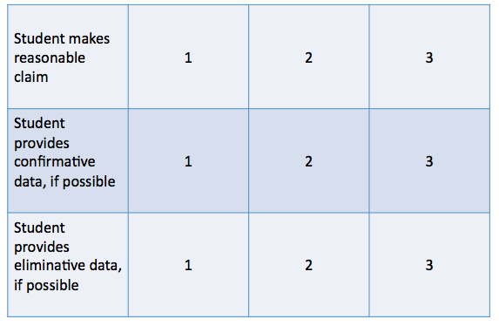

Logic Rubric: Advanced
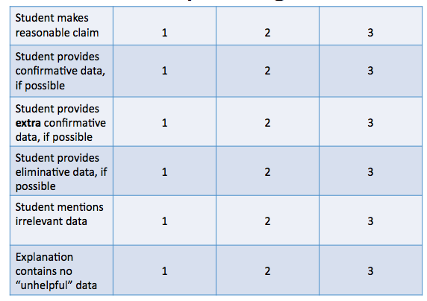
Writing Rubric
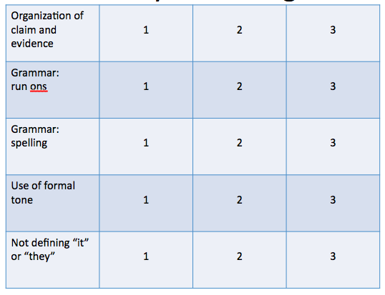
Smarter Balanced Craft Rubrics
http://www.smarterbalanced.org/wordpress/wp-content/uploads/2012/12/Performance-Tasks-Writing-Rubrics.pdf
