Final Assessment: Build-A-Particle
Teacher’s Guide
INTRODUCTION: In this assignment, students will combine their knowledge of surface area, size and nanotechnology to design a novel nanoparticle that addresses a current medical problem. These are authentic issues that nanoparticles are being used to address today. Students will read a short description of each problem, including information vital to designing an appropriate particle. Then, they will assess the functions and benefits of a variety of auxiliary molecules, currently used to functionalize nanoparticles for specific purposes. Students should identify characteristics that are useful to a given problem, design a particle that emphasizes these benefits and support their design with reasoning. Lastly, they will create SuperNano card that creatively discusses the design, function and “powers” of their particle.

OBJECTIVES:
Students will-
- Identify key components of a given problem
- Assess a variety of traits for usefulness in a given application
- Design a particle based on a desired function
- Support a proposed design with reasoning
- Demonstrate that nanoparticles are customizable for many uses

TIME: 75 min or 45 min + additional at home

MATERIALS:
- “Build-A-Particle” Student sheet

PROCEDURE:
- Explain to students that they will now use their understanding of nanoparticles and their many uses to design their own.

- They will analyze a chosen problem (1 out of 4 options), identify its key features, and design a nanoparticle that addresses these key features. Point out that all these problems are real problems that scientists are trying to use nanoparticles to solve.

- Explain that they will need to combine 1 base nanoparticle with any necessary accessory molecules to accomplish this task. Stress that only 1 base particle may be chosen, but any number of accessory molecules may be necessary. You may chose to print Table 1 (Base Particles) and Table 2 (Accessory Molecules) on different colored paper and have students cut out. This will allow for easy maneuvering and clarify the difference between the two types of Nano-pieces.

- Point out to students that they must be able to explain their use of every piece of their new nanoparticle- every part should have a specific purpose and reason for being there. There is more than one solution for each problem, but their reasoning is what matters.
ANSWER KEY and RUBRICS:
 | Key Features | Possible Nanoparticles | Explanation
Cancer Detection | - Detected through tumor markers  - Must detect small concentrations of compounds  - Use MRI for detection | Base Particle: SPIO  Accessory Particles:  APTES, Herceptin  Possible inclusions:  Raman detector, PEG, Calcein Probe | - SPIO must be used to function with MRI due to its magnetic properties  - Herceptin must be added to bind to tumor markers  -APTES is a linker that allows other molecules to bind to nanoparticles
Multiple Sclerosis | - Attacks nervous system  - Treatment must cross Blood Brain Barrier (BBB) | Base Particle: Lisosome  Other Possible Particles:  Silica, Chitosan  Accessory Particles:  APTES, Prednisolone, PEG | - Lisosome particles are ideal because of their ability to cross biological barriers and formation of vesicles  - APTES = linker  - Prednisolone, the MS medication, should be enclosed within the nano-lisosome  - PEG allows the molecule to cross the BBB
Asthma | - Causes inflation of airway tissue and production of mucus  - Results from low levels of Interferon-gamma  -Altered gene expression is a potential therapy | Base Particle: Chitosan  Accessory Particles:  None required, but could add APTES and PEG | - Chitosan interacts with Interferon, an important factor in Asthma  - Attaches to Mucus
Antimicrobial Resistance | - Microbes develop rapidly to combat chemical antibiotics  - Microbes have negative membranes | Base Particle:  Nanopolymer  Accessory Particles:  None Required, but could add APTES, PEG, Raman Reporters or Calcein AM | - Nanopolymer is ideal for its positively charged surface  - Additional molecules could either be to mask the positive charge until necessary or for detection purposes

SCORING RUBRIC: SuperNano Card and Activity Analysis
Overall Scoring may be adjusted by weighting specific categories more than others, such as accuracy and reasoning.

 | 0 | 1 | 2 | 3 | 4
Accuracy | Student provides no accurate information | Student provides some information, but with several major inaccuracies or misconceptions | Student provides mostly accurate information, but may have 1 substantial inaccuracy | Student provide mostly accurate information with only minor inaccuracies | All information is accurate- no mistakes or misconceptions.
Reasoning | Student provides no rationale for their design. | Student briefly explains 1 or 2 aspects of design. | Student explains most aspects of design, but is missing an entire component. | Student explains all aspects of design, but may lack some depth on 1 or 2 features. | Student explains all features completely and thoroughly.
Clarity | Student writing is in-comprehensible | Student writing is understandable, but with major weaknesses in organization and clarity. | Students writing is mostly clear, but may contain 1 large problem in either organization or clarity. | Student writing is clear and organized, with few minor problems in clarity or organization. | Student writing is clear and organized with no problems.
Creativity | Student shows no creativity- no drawing, color or descriptions. | Student shows limited creativity, but little to no effort. | Student demonstrates moderate effort and creativity. Includes color. | Student creates a visually clear, colorful, informative presentation, but the ad is not exceptionally unique or creative. | Student creates a visually clear, colorful, informative presentation that is also exceptionally creative and unique.

Total: / 20

POSSIBLE EXTENSIONS: Get Creative!
- Have the students build 3-D models of their nanoparticles.
- Conduct a Shark Tank-like competition where students make pitches to convince each other to “invest” in their particle.
- Make a commercial selling their product.
Example SuperNano Card:
(for Silica Nanoparticle from Lesson 3.2)

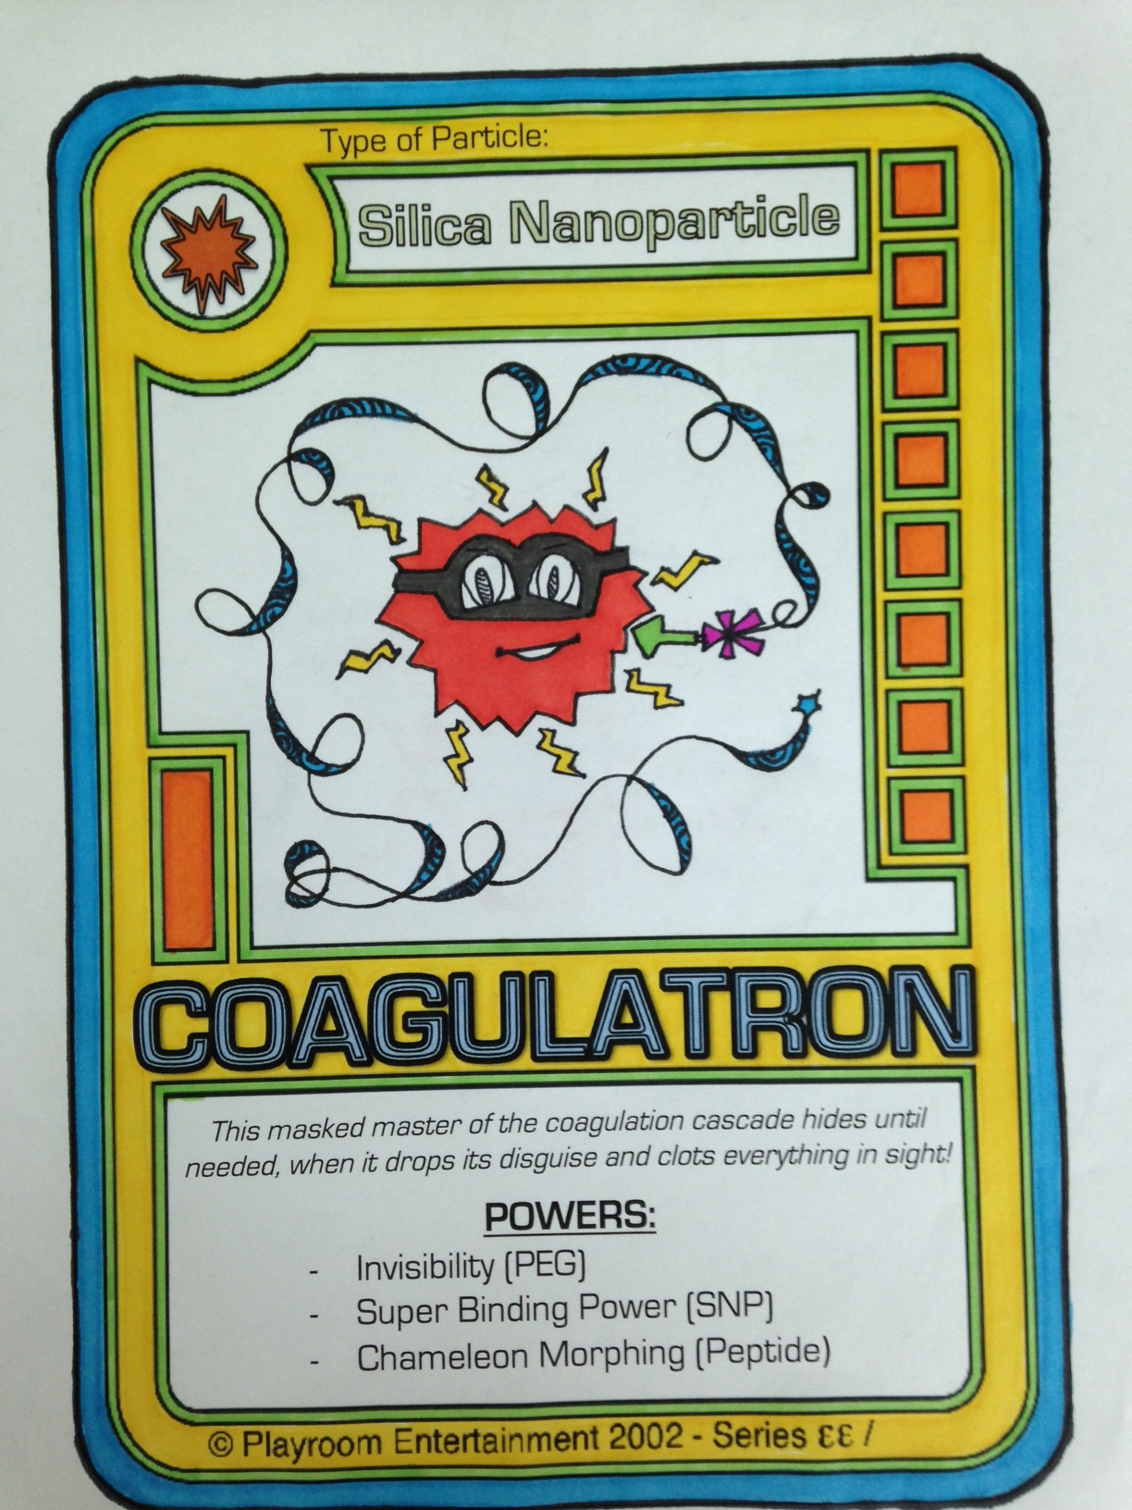

SuperNano Card Master:
(can be resized as needed)
