NAME________________

Surface Area and Size: Why do Small Things have Big Impacts?

*In this activity, you will explore the relationship between surface area, volume and size by making and examining origami cubes.*

QUESTION: How are surface area, volume and size related?

VOCABULARY:

**Volume-** The amount of space an object occupies (*Volume = length * width * height*)

**Surface Area-** The total area of the surface, or outer-most layer of an object (*Surface Area of a Cube = 6 * (length *width))*

MATERIALS:

* 1 large cube net (5 cm per side)
* 8 small cube nets (2.5 cm per side)
* Ruler
* Scissors
* Tape

DIRECTIONS:

1. Cut out all 9 cube guides (called nets).
2. Fold the paper inwards along the bold lines until you make a cube-shape.
3. Tape along the edges to hold the cube together.
4. Continue until all 9 cubes are completed.

ANALYSIS: *(Remember to show all work and complete units)*

Volume-

1. Using the formula for volume above, calculate the volume of the large cube.
2. Calculate the volume of 1 small cube. What is the volume of all 8 small cubes combined?
3. Compare the volume of the large cube to that of all the small cubes combined.
4. Calculate the volume of an even smaller cube with sides of 1 cm each. How many of these cubes would you need in order to equal the volume of the large cube?



Surface Area-

1. Using the formula for surface area above, calculate the surface area of the large cube.
2. Calculate the surface area of 1 small (2.5 cm per side) cube. What is the surface area of all 8 small cubes combined?
3. Compare the surface area of the large cube to that of the small cubes.
4. Calculate the surface area of a cube with 1cm sides. What is the surface area of 125 of these cubes combined?
5. Using the graph paper below, graph the relationship between you’ve seen so far between total surface area and size of particles. Be sure to label the scale for each axis.

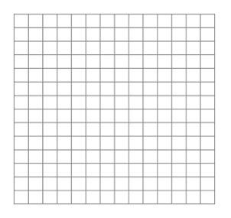

Total Surface Area

8 Cubes

(2.5 cm per side)

125 cubes

(1 cm per side)

1 Cube

(5 cm per side)

Number of Individual Cube per 125 cm3

1. Extension: Using the formulas for surface area and volume, find the mathematical relationship between surface area and volume.

TAKE HOME POINT:

Using *evidence* from your work above, construct a *claim* that addresses the question, how are surface area, volume and size related?