Analyzing “Mice in a Box” Experiment
Student Directions
Imagine a large carton with many mice inside (about 50). There are so many mice that their bodies pretty much cover the bottom of the box (include some air holes so that there is enough air for the mice to breathe). The graph below shows the rise in temperature in the box over 1.5 hours (20 ⁰C is about 70 ⁰F and 30 ⁰C is about 85 ⁰F).

Data:
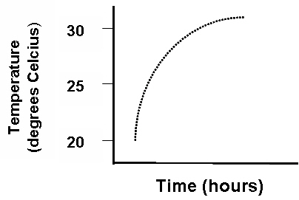

Analysis: Address the following specific questions.
- Assuming that no heat is entering the carton from external sources such as sunlight or a furnace, where is the heat coming from? What process results in this large heat production? What is the name of this process? (Hint: C₆H₁₂O₆ is involved)

- All living organisms engage in this metabolic process. Where does the process take place within each mouse? (Be as specific as you can). Why? Where in an insect or a plant would this metabolic process take place?

- In addition to the temperature, the concentration of CO₂ also changes in the box. In the space below, draw a graph that illustrates what you expect to happen with the concentrations of CO₂. Label hours on the x-axis (like the graph above) and concentration of CO₂ on the y-axis. Simply indicate an increase or decrease in levels of CO₂. Draw a dotted line showing how you would expect the CO₂ concentration to change. (Note – the holes in the box are not large enough to let much CO₂ to escape, so ignore this loss).

- Based on your discussion about both the given graph above and the one you made, describe in your own words the relationships between glucose (C₆H₁₂O₆) in the mouse’s cells, carbon dioxide, and heat energy.

