The Carbon Cycle Name: __________________________ Per. ______

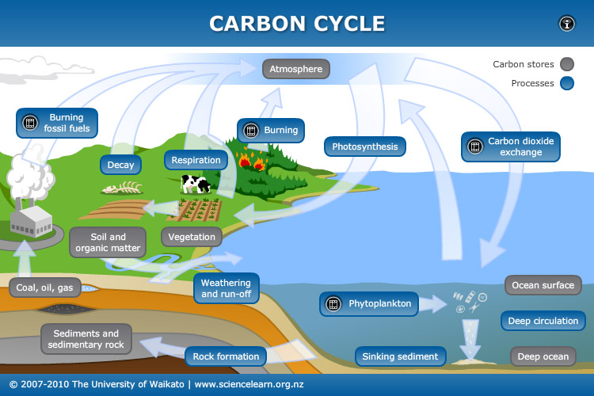

- The above diagram illustrates how nature recycles what natural resource?

- Carbon sources are natural systems that release carbon, usually in the form of carbon dioxide, into the atmosphere. Name two carbon sources.

- Plants use CO₂ from the atmosphere.
- Label this process on the illustration directing an arrow to the organism.
- What organisms carry out the process identified in part a?

- Wastes and dead organisms must be broken down in order for their basic components to be used again. Bacteria, fungi and worms break down these dead organisms.
- What is the name of this process?

- What would happen if the organisms stopped doing the process identified in part a?

- Carbon sinks are natural systems that take in and store carbon dioxide from the atmosphere.
- What are the carbon sinks in this cycle?

- How do humans use the materials in the carbon sink?

- What is the scientific name for the process listed in part b?

- How is the majority of electricity generated in the area where you live? Does the process involve the combustion of fuels? Check with your teacher if you are not sure.

- Many of the carbon-based fuels are categorized as fossil fuels because they formed from decayed organisms over millions of years. List as many fossil fuels as you can.

- Look at the sinks and stores. Think how long it can take for carbon dioxide to enter a sink and how long it can take to store it back in the atmosphere.
- Are the sink and store cycle of carbon dioxide occurring in equal amounts of time?

- How does our use of carbon affect the amount of CO₂ in the atmosphere?

Carbon dioxide (CO₂) is one of the greenhouse gases. These gases hold heat energy in the atmosphere, with raises the overall temperature of the Earth. This helps maintain the Earth’s biosphere, but also has led to environmental concerns. The more CO₂ in the atmosphere, the higher the Earth’s average temperature will be.
- What is another way in which human activity is increasing the amount of atmospheric CO₂ and what are potential global effects of these changes in CO₂ levels?

