China and Kazakhstan compete for carbon neutral Olympics
Last updated on 14 January 2015, 1:11 pm
Rivals set out visions for a green Winter Olympics in 2022 as sustainable development rises up agenda
www.rtcc.org/2015/01/14/china-and-kazakhstan...carbon-neutral-olympics

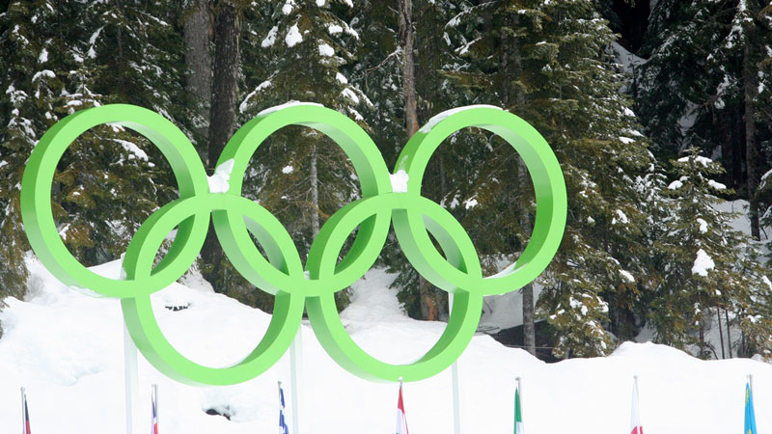
Pic: Megan Cole/Flickr
By Sophie Yeo
The Winter Olympics in 2022 will be carbon neutral if China wins its bid to host them in the snowy mountainous regions of Yanqing and Zhangjiakou.
Kazakhstan, Beijing’s only rival to the title of Olympic host, has also pledged to compensate for all emissions generated by the games.
These promises appear in the countries’ applications to the International Olympic Committee, submitted this month, where they describe their vision and the logistics behind the Winter Games.
“It is the solemn pledge of the Chinese governments at all levels that an environment of better quality shall be provided for the people and the Olympic Winter Games,” reads the Beijing submission, promising to integrate sustainable development into its planning.
It is not the first time that organisers have aspired to such a goal. Since the 2002 games in Salt Lake City, offsets have been used to neutralise the carbon impacts of the Winter Games. Both China and Kazakhstan say they will use the same approach.
These will have to compensate for the carbon emissions of building and running numerous stadiums, housing the athletes and the emissions from the flights that will carry spectators from around the world to watch the sport.
“To this end, efforts will be made to establish Beijing as a national carbon trading centre around 2020,” says the Chinese application, while Kazakhstan says it will make use of the UN’s international carbon market, the Clean Development Mechanism.
Offsetting
Both governments have yet to flesh out their plans with details; but a carbon neutral winter games is a show that China is capable of staging, says Li Shuo, senior climate and energy policy officer at Greenpeace East Asia. “They already have some practise from 2008 [Beijing Olympics] in going low carbon,” he told RTCC. “But for the Winter Olympics, if they’re going to go carbon neutral, they would definitely have to apply a lot of offsets.”
For China, this means more forests. The government has said it will set up a Beijing 2022 carbon emissions compensation mechanism that will be based on planting more forests, which store and absorb carbon dioxide from the atmosphere. In its bid to the International Olympic Committee (IOC), it mentions plans for an “eco-clean valley and forest belts” around the Guanting and Baihebu Reservoirs and the development of an ecological corridor in Beijing and Hebei. In the ‘Games Zones’, 70,000 hectares of forests will be created.
Kazakhstan promises it will compensate for the vast emissions of the Olympic Games by “making investments in reforestation projects, energy efficiency systems and the use of renewable energy resources”.
Simon Lewis from Team Planet, a sports and sustainability consultancy, said that offsets could be a “red herring” which prevents organisers reducing the actual carbon footprint of the event and protecting the pristine environments in which they take place. “My concern is that everyone is rushing to their chequebooks and going for the easy option, and it gives everything a nice green sheen, but I think not enough is being done by reducing the real climate impact of these games,” he told RTCC. Russia also pledged that their 2014 games in Sochi would be carbon neutral, but damage inflicted on the local surroundings during the construction of the Olympic site was a scourge to both environmentalists and residents alike.
China has promised to minimise the onsite environmental impact of the games by using “advanced energy-saving and eco-friendly technologies”, while it has promised that electricity generated by solar and wind power for lighting, transport and venue operations. In Zhangjiakou, 540 clean energy buses will be added to the network.
Kazakhstan, meanwhile, promises to protect the ‘Mountain Zone’, where some of the sports will take place, through measures that will prevent soil erosion, landslides and the loss of natural habitats and diversity. “Most competition venues, especially in the environmentally sensitive Mountain Zone, already exist. Therefore negative impacts related to construction induced by the Olympic Games will be minimal.”

- See more at: http://www.rtcc.org/2015/01/14/china-and-kazakhstan-compete-for-carbon-neutral-olympics/#sthash.5lIJPYMf.dpuf

