Design your own underwater craft: Student Instructions 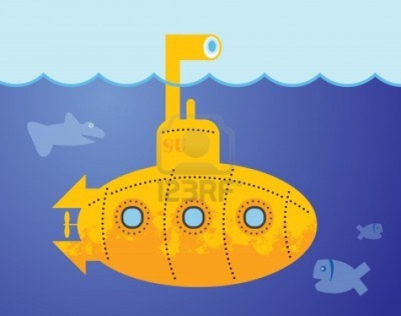
Imagine you are an engineer for Virgin Oceanic or WHOI. You and your team must develop a submersible that can reach Challenger Deep, 10,900 meters below the surface. Draw up a blueprint to show your design idea. Include a list of materials needed to build your submersible. The blueprint should indicate what parts are made of what materials if more than one type of material is used. Remember, a person and lots of cameras and other equipment must fit in there too! Incorporate ways for the passenger to see out and be able to record video while submerged.
***You will present your Blueprint to the class and explain WHY you chose your materials and design.
First, recall your answers to these questions:
- What do you, the designer, need to know about the machine before you can be sure it is safe to put in the water?
- How can you find this information without actually putting the machine in the water?
- If it does float, what must be done in order to make it sink?
- How do you know how much weight should be added?
- What must be done to make the machine quickly return to the surface?

Next, Fill out the back of this sheet in order to have a plan for your blue print

Materials: What kinds of materials support buoyancy?
What kinds of materials will resist pressure? WHY?

Shape: What shapes are most buoyant?
What shapes best resist pressure?
How do you know?

Where will the pilot sit?
What equipment is in there with him/her?
How much space should there be in order to stay buoyant and resist pressure?

Orientation: What orientation (vertical/ horizontal) will be most buoyant and resist pressure? WHY?

Equipment and power source: Will your sub be tethered to a battery, or have a portable battery?
How will the batteries be housed?

Release mechanisms: What if you have to drop weight? How can this be done quickly?

