Student Worksheet Name________________
Exploring Density and Buoyant Force with a Model Submersible
Pre lab questions:
- What do you, the designer, need to know about the machine before you can be sure it is safe to put in the water?
- How can you find this information without actually putting the machine in the water?
- If it does float, what must be done in order to make it sink?
- How do you know how much weight should be added?
- What must be done to make the machine quickly return to the surface?
- We need to know if the Trieste model is less dense than water and will therefore float. How can we determine the density of the model?
Finding mass: Using the balance, weigh the model and record its mass in both grams and kilograms: __________g__/___________kg
- Finding volume by displacement: We learned that an object will displace water equal to its own volume. Since our model is too big for a graduated cylinder, we will have to determine the volume some other way. Do you remember how Bill Nye did it?
Come up with a procedure to obtain the volume of the model and write it here:
Step 1:__________________________________________________________________________________
Step 2:___________________________________________________________________________________
Step3: ___________________________________________________________________________________
Step 4:___________________________________________________________________________________
Test your above procedure. If you make any changes to your procedure or decide to use a different procedure explain this here.
Step 1:____________________________________________________________________________________
Step2:______________________________________________________________________________________
Step 3: _____________________________________________________________________________________
Step 4:_____________________________________________________________________________________
Record the volume of displaced water as the volume of the model. _____________ (1ml= 1cm³ )

- Now calculate the density of your model by dividing its mass by its volume. _____________g/cm³
- Record these values in the data table below.
- Is the density of your model less than the density of water (1g/cm³ )? _____________
- And therefore, will the model float in water?______________
- How much mass must you add to make the density of the model the same as water? _________g
- How much mass must you add to make the model sink? ______________g
Mass of model (g)

Volume of model (cm³)
Density of model (m/v)
Volume of Water Displaced (cm³)

II. Calculating Buoyant Force
Pre lab Questions:
- How is an objects’ mass different from its weight?
- Describe buoyant force?
- State Archimedes’ Principle
- Will an object sink or float if its weight is less than its buoyant force?
First, calculate the buoyant force of the water on the model. Then, make your hypotheses. Lastly, answer the conclusion questions.
Making a Hypothesis: If I add ___________ grams of weight to the model, then it will be neutrally buoyant. If I add _____________ more grams of weight to the model, then it will sink.
Things to consider
- First, what do we need to know in order to determine the buoyant force?
- What unit will the buoyant force value be in?
- Now, calculate the buoyant force of the water on your model.
- What amount of weight must be added to the Trieste Model in order to make it neutral?
- By how much should this weight be increased in order to make the model sink to the bottom?
Now you can make an educated guess about the weight you need to add to the model for it to achieve neutral buoyancy and how much you need to add for it to sink.
Volume of displaced water (cm³)
Weight of displaced water (kg)
Buoyant force of water (N )
Weight to add for neutral buoyancy (kg)
Weight to add for sinking (kg)
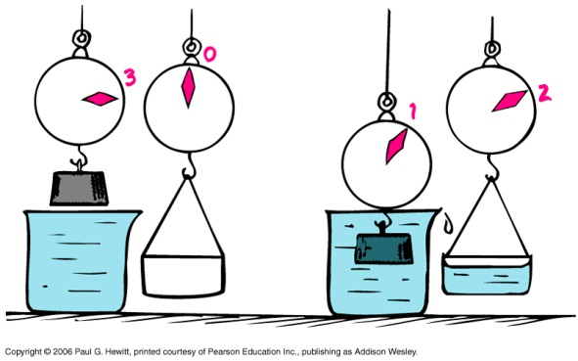
Conclusion: Structure your conclusion paragraph by answering these questions
- Did the model float in the beginning?
- Did the model sink?
- Did the model rise back to the surface?
- What changed about the model to allow it to rise?
- Was your hypothesis correct?
- Was the mass to make the model sink equal to the weight that made it sink?
- What mass made your model neutral?
- Which changed in this experiment, the density of the model, or the buoyant force on the model? Explain this answer.
- How would your results change if the model were put in salt water? Explain.
- How could you make your model sink more slowly?

