Designing Floats: Teacher notes
Adapted from: Activity 3.3 in
Teaching Physical Concepts in Oceanography: An Inquiry Based Approach
This activity adds a healthy competitive and creative component to a lesson on buoyancy. Give your students time to approach the task with trial and error. Probe them with questions, reminding them about the concepts learned from the Bill Nye video such as Archimedes’ Principle.
At the end of the lesson each team will test the floats in a larger aquarium set up by the teacher. The aquarium contains stratified layers of salt water colored blue and fresh water colored red. Make sure the salt water in the tank is the same salinity as the salt water the students are using for their trials. It is best to add the salt water to the tank first. Let a sponge float on top of the water against the wall of the tank then, using a large syringe, slowly add the fresh water, letting it run down the side of the tank and hit the sponge. This will prevent the waters from mixing and give you the stratification you want.
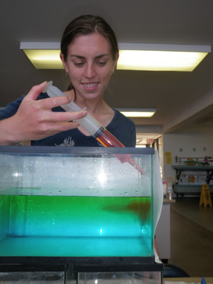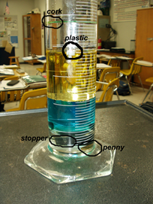
The figure on the left shows a student adding the fresh water layer over top the salt layer. The figure on the right shows a density column with different items floating or sinking according to their densities. Making a density column is shown in this link: http://www.youtube.com/watch?v=AOytS9omeqk&feature=player_detailpage
Good Materials to Have (you don’t need everything , these are only examples)
-Weights (washers, pennies, little green army men, etc.)
- tape, drinking straws, bubble wrap, packing peanuts, corks, pipe cleaners, duct tape, balloons, rubber bands, modeling clay
- For construction: glue gun, tape, thumb tacks, paper clips, staples
Probing Questions for Your Students
1. What do you know about an object if it is floating on a fluid?
2. What do you know about an object if it is sinking in a fluid ?
3. What do you know about a liquid if it is sinking in another fluid?
4. What do you know about the densities of the layers in this tank?
5. What do you know about the density of an object that sits between these layers?
6. How can you manipulate the densities of your floats?
7. What materials will increase the density of your float?
8. What materials will decrease the density of your float?
9. What will happen if you increase the density of your float too much?

