Ocean Zones Fill In: Organisms
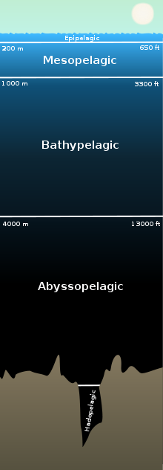

Ocean Zones Fill In: Organisms
While viewing the film Blue Planet: Deep Ocean, take notes and fill in the
boxes for each zone with the corresponding animals and their adaptations.
You do not have to write about every animal discussed in the film but do your best to
write about one animal in each zone.

