Name______________________ Date_____________Period_____

**Polymer Unit Test**

**Multiple Choice Questions:**

1. Due to the present of carbon atom in polymers all large biological molecules are made of ____  
a) covalent bond c) metallic bond  
b) ionic bond d) triple bond

2. Which one **is not** a polymer  
a) carbohydrates c) nucleic acid  
b) proteins d) carboxylic acid

3. Amino acids are the building blocks of _______  
a) carbohydrates c) nucleic acids  
b) proteins d) lipids

4. Which one is a natural polymer?  
a) cellulose c) polygon  
b) polypropylene d) Kevlar

5. Which substance is made up of many monomers joined together in long chains?

a) salt c) ethanol

b) cellulose d) polygon

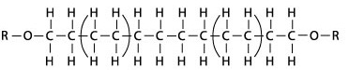

6. Polyethylene picture on the right is a ________  
a) monomer c) copolymer  
b) polymer d) elastomer

7. Which pattern is not a copolymer  
a) CCDDDCCDDDCCDDD c) BBBBBBBBAAAAAAA  
b) CCCDDDCCCDDDCCC d) AAAAAAAAAAAAAA

8. Which one **is not** a characteristic of thermoplastic  
a) no cross links between chains c) resistance to heat won’t melt  
b) can be molded d) commonly used as plastic bottle

**Free Response Questions:**

9. Many polymers occur in nature. Name any two naturally occurring polymers.

_______________________ and ______________________

11. Describe what is meant by the term "polymer".

12. What will happen when we begin heating each of the polymers below after it cured?

a) A thermosetting(polymer)

b) A thermoplastic (polymer)

13. Below is ethylene, the basic monomerfor polyethylene. Draw polyethylene structure.



14. "Cross-linkers" are atoms or groups of atoms that will bind chains of polymers together. What will happen if the number of cross-linkers increased?

15. Define biodegradable

**Polymer Unit Test**

**(ANSWER KEY)**

**Multiple Choice Questions:**

1. Due to the present of carbon atom in polymers all large biological molecules are made of ____  
**a) covalent bond** c) metallic bond  
b) ionic bond d) triple bond

2. Which one **is not** a polymer   
a) carbohydrates c) nucleic acid  
b) proteins **d) carboxylic acid**

3. Amino acids are the building blocks of _______  
a) carbohydrates c) nucleic acids  
**b) proteins** d) lipids

4. Which one is a natural polymer?  
**a) cellulose** c) polygon  
b) polypropylene d) Kevlar

5. Which substance is made up of many monomers joined together in long chains?

a) salt c) ethanol

**b) cellulose** d) polygon



6. Polyethylene picture on the right is a ________  
a) monomer c) copolymer  
**b) polymer** d) elastomer

7. Which pattern is not a copolymer  
a) CCDDDCCDDDCCDDD c) BBBBBBBBAAAAAAA  
b) CCCDDDCCCDDDCCC **d) AAAAAAAAAAAAAA**

8. Which one **is not** a characteristic of thermoplastic  
a) no cross links between chains **c) resistance to heat won’t melt**  
b) can be molded d) commonly used as plastic bottle

**Free Response Questions:**

9. Many polymers occur in nature. Name any two naturally occurring polymers.

**Any two of these are correct: cellulose, polysaccharide (carbohydrate, starch), protein, DNA, silk, cotton fibers,**

11. Describe what is meant by the term "polymer".

**A chain of repeating units called monomers that connected to each other**

12. What will happen when we begin heating each of the polymers below after it cured?

a) A thermosetting(polymer)

**It will not melt**

b) A thermoplastic (polymer)

**It will start to melt and be pliable to mold into any shape**

13. Below is ethylene, the basic monomerfor polyethylene. Draw polyethylene structure.



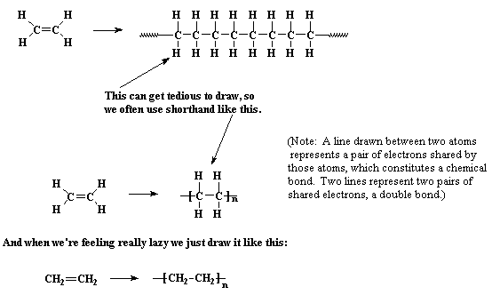

**Answer: Polyethylene drawing above**

14. "Cross-linkers" are atoms or groups of atoms that will bind chains of polymers together. What will happen if the number of cross-linkers increased?

**More cross-links that present in a polymer will make the structure stiffer, harder to bend, less flexible, high viscosity (doesn’t flow as well)**

15. Define biodegradable

**Any materials that are able to break down, decompose back into its elemental form by the natural environment**