Lesson #3: Build An Integrated Sensor System
Student Handout

Purpose:

Materials: paper, tape, 400 ml beakers, various dilutions of conductive paint, paint brushes (2” foam is good), alligator clips, voltmeter, ManyLabs grove arduino setup, ManyLabs software, easy-set-up light box, light sensor, handouts

Procedures:

For Set Up

- Collect 5 squares of paper, label one side of each square with your number and paint the opposite side of each with each diluted paint. Make sure to have students paint one continuous strip as carefully as possible. Let dry for 30 minutes to overnight. Note that very dilute solutions (1:5 and higher will take less time).

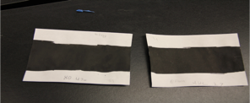

- Make sure microcontroller, or voltmeter (if computer isn’t working) is set up properly (check with teacher). Run in Mozilla Firefox, or Google Chrome.
- Attach alligator clips according to diagram (Y=neg, R=pos, W=connection) to shaded circuit area, see below:

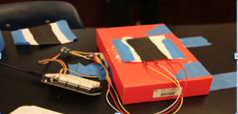

- If computer is set up properly, open Manylabs “Exploring Graphite Potentiometers” and complete 1st step (making sure microcontroller is recognized and which com port is correct).
- Prepare the light box for students but have them set it up. You can use any shoebox, small package box (I used a Sparkfun electronics package box). Set up your light box and put the “light sensor” under it. Make sure it is “centered” under the shaded-in area and tape it down. Here is an example:

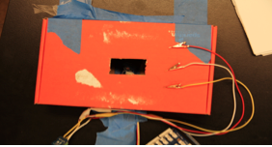

- NOTE: This depends on color of alligator clips. Y= yellow, R= red, and W= white. Pre-connect your 1st shade by clamping alligator clips (ex: Y=ground, R=5V, W=sensor) such that Y and R are opposite each other, and W is attached in the center.

For Running Sensor (If ManyLabs is working)
- Run the plotter program in Mozilla Firefox to see what the initial value of light is without your shades (700+), and let it run. You will see “Light” and “Voltage” values that fluctuate. If it doesn’t do anything, check with teacher (this may mean restarting webpage, replugging in the microcontroller, or updating microcontroller.
- While the program is running, tape down the shade and make sure the tape is not touching the paint. Attach the alligator clips in the manner as seen in step #3 above.
- Click “record 1:1” box and the values will show in the boxes to the side.
- Detach the shade and attach the next dilution shade as said in #8 above.
- Click “record 1:2” box and the values will show in the boxes to the side and a graph may show up.
- Repeat Step #8 and click on the subsequent “record 1:x” boxes for the remainder of the shades.

SEE EXAMPLE BELOW:
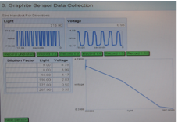

Results: Write down the voltage and light values for each dilution in the chart below:

Dilution Factor | Light Value | Voltage
[undiluted]
1:2
1:3
1:4
1:10

Conclusion: Answer the following discussion questions below.

- Reattach the 1:4 dilution shade and try different positions for the W alligator clip (or whichever color you designate). What does the “voltage” sensor tell you specifically? What type of sensor is this? How can you tell?

- While running the experiment on the computer, what differences did you notice with each square? Note the position of the “center” alligator clip and the voltage values for all dilutions.

- What does the change in light values actually mean? Explain.

- What are some possible errors you encountered while doing this experiment? List at least three and explain them.

