Lesson #1: Introduction to Basic Circuitry
Student Handout

Purpose:

Materials: Little Bits Starter kits and parts
Computer
ManyLabs software, worksheets, Manylabs arduino uno set up with knob, button, light sensor, LED, tilt sensor, and screw terminal (optional)
Procedures:
Lesson 1a: Using Little Bits to Explore Circuits
https://community.littlebits.cc/lessons/101-lesson-learning-input-and-output-the-littlebits-way
Start by “manipulating the bargraph bit”, by joining the power bit, button bit and bargraph bit together. Conduct each of the 11 circuits in succession and answer the following questions. As you complete each circuit, try to think of examples of real applications for these circuits.
Lesson 1b:
Results:
Activity 1a
1. Circuit 1: Power + Button + Bargraph
a. What happens when you press the button?

b. What bit(s) would you need to add/replace and where would you put it/them in order to change the number of bars lit up at any given time?

2. Circuit 2: Power + Button + LED
a. What happens when you press the button?

b. If you wanted to turn the LED on or off, what part(s) would you need to add/replace?

c. How would you light up a Blue LED in this circuit? Which part(s) would you need to add/replace?

3. Circuit 3: Power + Button + RGB LED
a. What happens when you press the button?

b. What would you have to add/replace to make a flashing light?

c. What would you have to add/replace light up a Yellow LED?

4. Circuit 4: Power + Button + Vibration Motor
a. What happens when you press the button?

b. What would you add/replace to create less vibration?

c. How many different combinations of circuits can you create to lessen vibration? Give one example.

5. Circuit 5: Power + Dimmer + Bargraph
a. What happens when you connect the circuit?

b. Which way would you turn the dimmer to light up more bars? Fewer bars?

c. What part would you add/replace to create a flashing LED every second?

6. Circuit 6: Power + Dimmer + LED
a. What happens when you complete the circuit?

b. What do you have to do for the LED to dim?

c. What part would you add/replace to turn the LED off/on and where would you put it in the circuit?

7. Circuit 7: Power + Pressure + Bargraph
a. What happens when you press the pressure sensor?

b. If you want to light a maximum of 3 lights, what would you need to add?

c. How would you get the bargraph to flash every second?

8. Circuit 8: Power + Pulse + Bargraph
a. What do you see when you complete this circuit?

b. Is it possible to change the speed of flashing LEDs? How so?

c. How could you only light up 2 bars on the graph? What would you need to add?

d. How can you vary the number of flashing LED bars lit up by using pressure?

9. Circuit 9: Power + Pulse + Bargraph + Button + Led
a. What do you see when you complete this circuit?

b. Is it possible to dim the LED? How so?

c. How do you vary the number of bars that light up?

d. How do you get the LED to flash?

10. Circuit 10: Power + Pulse + Dimmer + Bargraph + Vibration Motor
a. What do you see when you complete this circuit?

b. Is it possible to maintain 5 flashing bargraph lights while changing the vibration speed? How so?

c. What would happen if you replace the Pulse sensor with a Pressure sensor?

11. Circuit 11: Power + Dimmer + Vibration Motor + Button + Bargraph
a. What do you see when you complete this circuit?

b. What happens when you adjust the dimmer?

c. What happens when you press the button?

Lesson 1b: Using ManyLabs Software to explore logic statements
Once you are finished with the Little Bits section and have answered the questions above, follow the guided statements to build circuits on ManyLabs. Go to www.manylabs.org, click on the “sensors” tab under “Hubs” and click on “Sensor Circuits”. Make sure arduino setup is plugged in and follow screen instructions.
See example below:

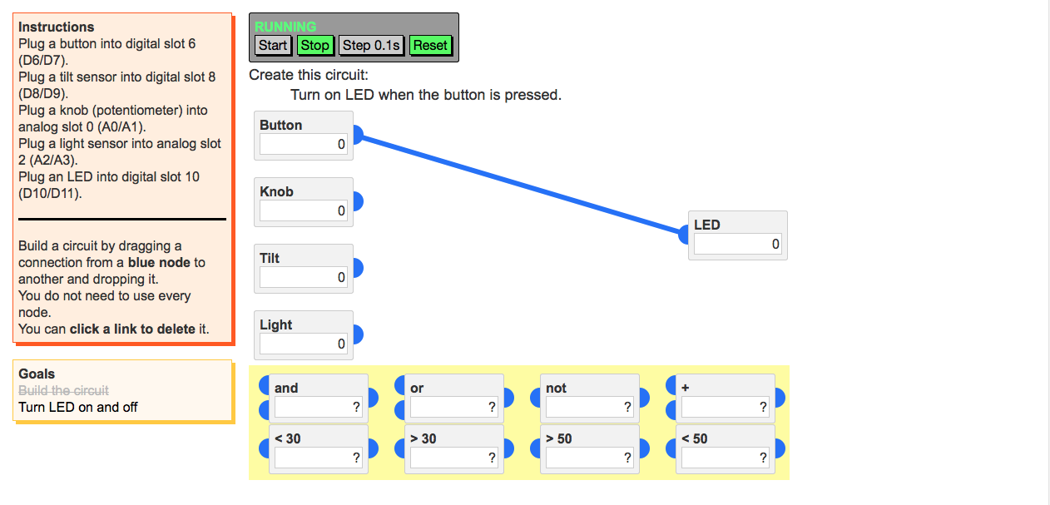

Results: To keep a chart of logic statements, place a “Y” for each part “used” to complete the circuit in the table below after completing the task on the computer for each exercise:

Circuit # | Button | Knob | Light | Tilt | And | Or | Not | + | <30 | >30 | <50 | >50
1
2
3
4
5
6
7

Conclusion:
- What happened when you connected the Little Bits together and lit up the bargraph?

- What bit(s) will you need to add and where will you add it/them to change the output of the bargraph to light up only 2 bars rather than all 5?

- On the ManyLabs exercise, what does connecting the blue dots represent?

- What do the boxes with >30, <30, >50 and <50 mean?

- What does it mean when you insert the “and”, “or”, or “not” button?

- How difficult was the circuit at the very end? Explain the complexity.

