Name______________________ Date_____________Period_____
Lab: Testing Factors that Affect Biodegradable Plastic
Introduction:
Due to its low cost and moldable property, the production of plastic products has increased since it modern discovery of Bakelite in early the 1900s. All plastics are made from petroleum, consisting of hydrocarbon chain and they are not biodegradable in landfills. Plastics need to be exposed to UV, moisture, and enzymes for hundreds of years to be fully broken down. In 2010 only 30% of plastic products in the US have been effectively recycled. The amount which synthetic polymers contribute to the weight of solid waste will continue to go up as the use of plastics increases.

Table 1: United States’ plastic waste percentage by weight
Year | All Total Waste | Percent of Plastics Waste
1960 | 88.1 million tons | 2.7%
1985 | 166.3 million tons | 7.2 %
1995 | 217.3 million tons | 8.4 %
2005 | 252.7 million tons | 9.8 %
2010 | 249.9 million tons | 12.4%

Source: http://www.epa.gov/osw/nonhaz/municipal/index.htm

As an alternative to petroleum based plastic, bioplastics are derived from renewable resources from plant based materials such as cellulose, pectin, and starches. They are designed to biodegrade in landfills or compost bins when disposed of. After they compost these bioplastics waste can then be used as fertilizer to support growth for new plants and complete the renewable cycle. Polylactic acid (PLA) produced from sugarcane and polyhydroxyalkanoates (PHA) produced from bacteria are some of the current materials used in making bioplastics.
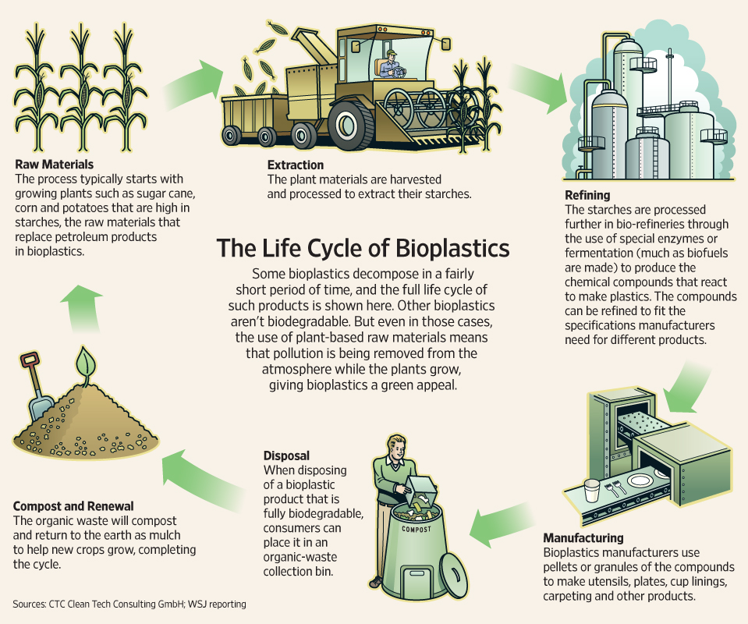
Figure 1: Renewable cycle for bioplastics

We will be comparing between bioplastics and petroleum based plastics to see how they degrade under controlled conditions. We are working with two bioplastics materials: polyvinyl alcohol (used in lab #1 and lab#2) and casein. Casein is a protein found in mammalian’s milk and found in all cheese products. In addition to food products, casein has been used commercially since the late 1890s and revolutionized the shirt buttons industry. It fell out of favor during WWII due to limited supply of milk as milk was rationed as food. New discovery of petroleum based synthetic plastics was preferred over casein because unlike casein, they are moldable even after it cured. This is why we are able to recycle plastic bottles and reshape it into other things.
Objectives:
- Making bioplastics from casein protein and polyvinyl alcohol
- Compare factors such as ph, salinity, UV and its ability to biodegradable materials
Materials:
Part 1 Part 2
whole milk glass stirrer 20ml glass vials (3)
low fat milk 10ml graduated cylinder pH 9 alkaline solution
white vinegar cheesecloth salty solution
400ml beakers (2) thermometer tap water
hot plate scale 10ml graduated cylinder
rubber band scale

Safety Precautions:
1. Vinegar is slightly acidic wear goggles
2. Hot plate will be hot use caution

Pre-lab:
a) What is the raw material used to make all plastics?
____________________________________________________________________________________________________________________________________________________________
b) How long does it take for plastics to break down in landfills?
____________________________________________________________________________________________________________________________________________________________
c) Define biodegradable
____________________________________________________________________________________________________________________________________________________________
d) Explain the difference between bioplastic and plastic
____________________________________________________________________________________________________________________________________________________________
f) What is casein? Where can you find it?
____________________________________________________________________________________________________________________________________________________________
g) Can we mold casein into a different shape once it cured?
____________________________________________________________________________________________________________________________________________________________

-Teacher’s approval _____________________________ (cannot start without signature)

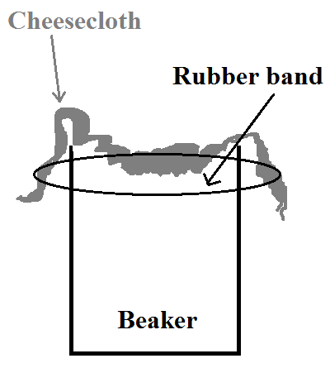
Procedure Part 1: Producing bioplastics with casein from milk
1. Turn on your hot plate to 150 Celsius
2. Obtain 200ml of low fat milk in the one of the 400ml beaker
3. Place your beaker on the hotplate (stir once in a while)
4. Use the graduated cylinder to get 8ml of vinegar
5. If your milk is 40 Celsius or above then pour the vinegar in and stir
6. Vinegar dissolves the calcium in milk that binds casein and cause the protein to curd and clump together
7. Set up your cheese cloth and the second 400ml beaker similar to the picture on the right (make sure you secure the cloth with a rubber band)
8. Slowly pour your casein produce over the cheese cloth
9. Add tap water to your milk beaker and repeat step 8 to get the small amount of casein in the beaker
10. Wash the milk beaker, obtain whole milk and repeat the process
11. Wrap the curds in the cheesecloth or hold them between your hands and squeeze out the extra liquid
12. The curds will be crumbly at first—press, knead and mold them into square shape
13. Weight, record and store overnight to let it dry them into a solid plastic.
Table 1: Producing bioplastics with casein from milk
Low fat milk casein | Whole milk casein
Weight (g):______________________ | Weight (g):________________________
3 physical description of casein | 3 physical description of casein

Procedure Part 2: Testing factors that degrade bioplastics
1. Cut out 3 small pieces of your dried whole milk and 3 pieces of low fat milk casein plastic
2. Pour 10ml of tap water into one of the 20ml glass vial, label your vial with masking tape
3. Pour 10ml of alkaline water into another 20ml glass vial, label vial
4. Pour 10ml of salt water into another 20ml glass vial, label vial
5. We will be testing the low fat milk first, weight the first casein piece (record) and place in the tap water vial. (start your timer)
6. Weight the second casein piece (record) and place in the alkaline water vial.
7. Weight the third casein piece (record) and place in the salt water vial.
8. Wait for ten minutes, remove all the casein pieces, dry them well with paper towel
9. Reweight and record in the second column
10. Place the same pieces of casein back into its vial
11. Turn your hot plate to 100 Celsius and place all vials on top of the hot plate
12. Wait for ten minutes, remove the vials from your hot plate
13. Dry the casein pieces, weight and record in the thirds column
14. Repeat step 5 to 13 for whole milk casein
Table 2: Testing factors that degrade bioplastics
Low fat milk casein | Column 1  Weight (g) | Column 2  Weight after 10 minutes (g) | Column 3  Weight after 10 minutes with heat (g)
Tap water
Alkaline water
Salt water
Whole milk casein
Tap water
Alkaline water
Salt water

Table 3: Analyzing the amount weight loss when soaked in solution
Low fat milk casein | Weight lost at room temperature  (Column 1 – Column 2) | Weight lost under heat  (Column 2 – Column 3)
Tap water
Alkaline water
Salt water
Whole milk casein
Tap water
Alkaline water
Salt water

Procedure Part 3: Testing polyvinyl alcohol film
1. Obtain the polyvinyl alcohol film
2. Measure the thickness, length and width of the film (record)
3. Calculate the volume (length x width x thickness)
4. Record the amount it takes for the film to dissolve in water
5. Place film #1 in tap water and start your timer
6. Record the time when all dissolved in water
7. Repeat for film #2

Table 4: Polyvinyl alcohol film water soluble
 | Thickness  (mm) | Length  (mm) | Width  (mm) | Volume  (mm) | Dissolved time (minute)
Film #1
Film #2

Conclusion Questions:
1. Based on your data at room temperature, under which condition did the low fat milk casein lost the most weight? ____________________________________________________________ ______________________________________________________________________________

2. Based on your data when heated, under which condition did the low fat milk casein lost the most weight? __________________________________________________________________
______________________________________________________________________________
3. Based on your data at room temperature, under which condition did the whole milk casein lost the most weight? _______________________________________________________________
______________________________________________________________________________

4. Based on your data when heated, under which condition did the whole milk casein lost the most weight? __________________________________________________________________
______________________________________________________________________________

5. Based on the casein properties, what are some (3-5) useable objects you can make using casein? _______________________________________________________________________
____________________________________________________________________________________________________________________________________________________________

6. Does the size of the polyvinyl alcohol film affect the rate that it dissolves?
____________________________________________________________________________________________________________________________________________________________
7. List 3 objects that you can use polyvinyl alcohol film to make.
__________________________________________________________________________________________________________________________________________________________________________________________________________________________________________

8. List 3 objects that do you not want to be made from polyvinyl alcohol.
____________________________________________________________________________________________________________________________________________________________
______________________________________________________________________________

