Name______________________ Date_____________Period_____

**Lab: Making Slime through Cross-linking Process (Answer Key)**

**Introduction:**  
Cross-linking is a process that bonds two or more polymer chains together decreasing a material’s elasticity and making it more rigid. Charles Goodyear discovered vulcanization in 1839, a process that changed the elastic rubber to improve its strength. Vulcanization occurs when sulfur is added to rubber causing them to cross-link and harden. Without the cross-link with sulfur, rubber remains a soft and easily deforms. Thanks to his discovery, we are able to use vulcanized rubber and use it in many industries including making automobile tires.

In today’s lab, you will experience cross-linking and observe how it changes polymers’ physical properties. You will be working with polyvinyl alcohol (PVA) and borax (sodium tetraborate) to create poly(vinyl alcohol) borate gel commonly known as “slime”. Figure 1 illustrates how one linear PVA chain attached to another PVA chain by adding borax (Na2B4O7). Boron allowed cross-linking to happen, a process that connect or bond two polymer chains together through covalent bonds. This bridge between the PVA chains holds the molecule, making it stiff, stronger and more viscous, reducing its flow rate. Slime exhibits some unusual properties, exhibiting both properties from liquid phase as well as solid phase. This is referred to as a non-Newtonian fluid that dilates or expands depending on the amount of stress placed on it.

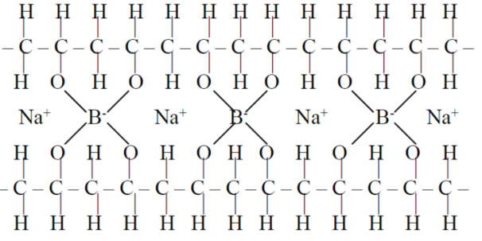

**Figure 1**: Cross-link PVA and borax yielding slime

**Objectives:**

* Understand cross-linking and how it effects polymers’ property
* Explore basic qualitative polymer properties
* Observe polymerization reaction process

**Materials:**25ml graduated cylinder (PVA only) wooden stirrer 4% wt. PVA solution  
10ml graduated cylinder (Borax only) cup 4% wt. Borax solution

**Safety Precautions:**1) Wear goggles at all times. PVA and Borax could burn your eyes.  
2) Take care to keep the chemicals and the Slime away from your clothes or cloth may produce permanent stains. Pick up immediately if pieces fell on the table top or the ground.   
3) Do not dispose of anything down the drain to prevent clogs from occuring

**Pre-lab:**   
a) Define polymer in your own words  
__Polymer is a long chain of monomers attached together_______________________________  
____________________________________________________________________________________________________________________________________________________________

b) PVA is an abbreviation that stands for __Polyvinyl alcohol ___________________________  
  
c) The 25ml graduated cylinder is use for only which solution? __4% wt. PVA solution ______  
  
d) How many milliliters of PVA do you need? _______25ml________________________

e) What are the safety precautions for this lab?  
___Wear goggles, do not get slime on your clothes or furniture, do not dispose anything down the drain______________________________________________________________________ ______________________________________________________________________________  
  
f) Can you take the polymer home? ____________No_______________________________________

g) Define cross-link.  
__ Cross-linking is a process that bonds two or more polymer chains together decreasing a material’s elasticity and making it more rigid _________________________________________

-Teacher’s approval _____________________________ (cannot start without signature)

**Procedure:**1. Read the lab and answer the following pre-lab questions (must be approved before you can start getting lab materials)  
2. Use the “25ml graduated cylinder” to get 25ml of 4% PVA solution  
3. Use the “10ml graduated cylinder” to get 5ml of 4% borax solution  
4. Add PVA solution into the cup first (if you want color polymer then place one drop of food color in the cup) start stirring with the wooden stirrer when you add the Borax solution into the same cup  
5. Observe the polymerization reaction   
6. Once it completes the slime is safe to handle with your hands (observe and record its properties)  
  
*Clean Up Procedure:*   
1. Do not rinse the graduated cylinders   
2. Return your slime to me  
3. Dispose of the wooden stirrer as well as the cup in the trash can

**Data and Analysis**1.Describe the reaction rate for this polymerization reaction to occur.  
_The reaction rate is fairly fast, at the right proportion of Borax and PVA it takes about one to two minutes with stirring to polymerize. ___________________________________________ ______________________________________________________________________________

2. Describe the properties of slime and how it feels in your hands  
__It feels slightly moist and flows slowly when left on the table. It is soft and has some force resistance when pushing against the polymer. ________________________________________ ______________________________________________________________________________

3. What are the physical properties that changed as a result of the addition of sodium borate solution to the polyvinyl alcohol solution?  
_It became thicker and its viscosity decreased and cannot flow as easily as before ___________ ______________________________________________________________________________  
  
4. Describe the chemistry that allowed the two liquids to change its physical property (hint Figure 1).  
__Boron atoms from borax act as a crosslink and connects different chains of PVA polymers together and decrease its viscosity making it into a slime from its liquid phase before crosslinking ___________________________________________________________________

5. Describe what happen when you pull the Slime apart rapidly?   
___It breaks into two pieces ______________________________________________________ ______________________________________________________________________________

6. Describe what happen when you stretch it and pull the Slime apart really slowly?  
___It slowly stretched out and elongated into a thin string _______________________________ ______________________________________________________________________________

7. Describe what happen when you gently apply pressure to the slime when it’s between the palms of your hands?

___The slime flattens against your palms ____________________________________________ ______________________________________________________________________________  
  
8. Describe what happen when you roll a piece of Slime into a ball and drop it about 1 foot above the table?

____It slightly bounces as it hits the table surface _____________________________________ ______________________________________________________________________________

9. What happen if you let the slime sit on your table for 1 minute?   
___It slowly spread out and cover the surface of the table ______________________________ ______________________________________________________________________________

10. Is slime a liquid or solid? Explain your reasons.

__Slime is neither liquid or solid. It exhibit properties of both phases and is actually classified as Newtonian fluid ________________________________________________________________ ______________________________________________________________________________

11. What is a non-Newtonian liquid? (you might have to use google to answer this question)  
__It can flow and stretches from stress _____________________________________________ ______________________________________________________________________________

12. What do you think will happen if someone mistakenly used the same graduated cylinder to get both the borax solution and the PVA solution?  
___The solution will started to crosslink and you’ll have sticky slime at the bottom of the cylinder that wil be hard to clean __________________________________________________ ______________________________________________________________________________  
  
13. What do you think will happen if you repeat the experiment but adding more sodium tetraborate to your cup (your thoughts only)?  
__The solution will be less slimely since all the borax are used up and the extra borax with lots of water are floating around in the mixture making it more liquidity ______________________ ______________________________________________________________________________

14. Draw the structure for a vinyl alcohol molecule.

  
  
15. Find and circle the repeating monomer subunit in the polyvinyl alcohol molecule.

16. What will happen to the "strength" and "flexibility" of the polymers as the number of cross-linkers increase?

_As more crosslinking occurs the polymer is stronger and more rigid but it loses flexibility and will snap (break) instead of bending _______________________________________________ ______________________________________________________________________________

17. A "branched polymer" is formed when small chains attached along the body of the main long polymer chain. Draw a branched polymer structure.

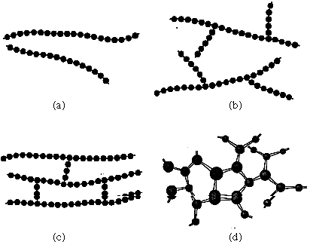

A picture similar to this

**Conclusion:**

Write a paragraph summarizing the physical properties of slime. Explain the role of cross-linking in slime. Explain the difference between polymerization reaction and cross-linking.

________________________________________________________________________________________________________________________________________________________________________________________________________________________________________________________________________________________________________________________________________________________________________________________________________________________________________________________________________________________________________________________________________________________________________________________________________________________________________________________________________________________________________________________________________________________________________________________________________________________________________________________________________________________________________________________________________________________________________