A set of Activities Exploring Synthetic and Environmentally-friendly Polymers, their Properties and Applications
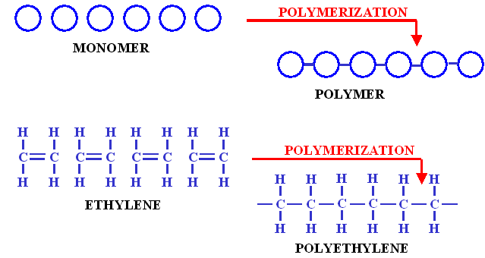
Chuong Vu
cvu805@gmail.com
Eleanor Roosevelt High School
Corona-Norco Unified School District

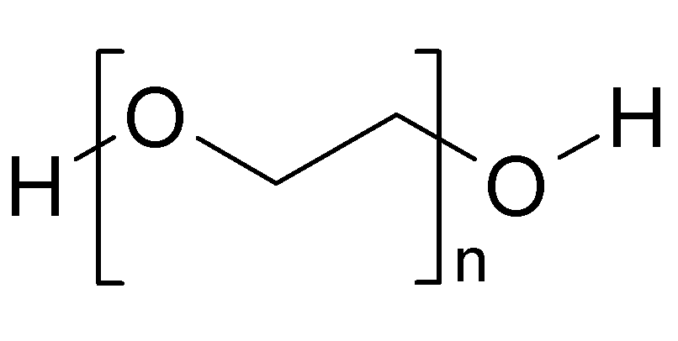
Polyethylene Glycol (PEG)

Material Research Laboratory
UC, Santa Barbara
RET II 2013
A set of Activities Exploring Synthetic and Environmentally-friendly Polymers, their Properties and Applications
Project Overview
Abstract:
This compact two week long high school chemistry curriculum provides basic lessons on polymers addressing CST standards as well as extension activities that focus on innovation and creativity. The three main themes of this project are introduction to polymers, applications of polymeric materials, and polymers for the environment. Hands-on explorations of polymer synthesis include experiments with polyvinyl alcohol (PVA) and acetone (“fibers”), PVA and borax (“slime”), mixtures of silicone and corn starch (“oogoo”), a novel material for the science classroom, and casein “bioplastic” obtained from combining vinegar and milk. Modeling of polymerization is explored via polycaprolactone thermoplastic (“hand moldable plastic”) and activities exploring various gadgets using oogoo and extension units on the degradation of casein, super-absorbant hydrogel and soft robotic devices are also introduced.
Introduction to RET I Research Project:
My RET I research project focused on creating polyethylene glycol (PEG) with hydrophilic functional groups for pharmaceutical applications. Polyethylene glycol is a nonimmunogenic polymer that can be used as a carrier media to decrease opsonization (immune response) of drugs from the human body and increase blood circulation time. Thus, drugs attached to PEG will have a longer half-life and potentially reduce the dosage amount and treatment duration.
To exploit the properties of PEG, drugs may be PEGylated by reaction of a drug molecule with carefully selected reactive end-groups on PEG. However, PEGylation is typically limited to one drug molecule per PEG. My project focused on a novel approach that will enable attachment of many functional groups along the backbone of PEG by copolymerization of ethylene oxide with propargyl glycidyl ether.
Through my experience, I was exposed to the complicated and time consuming chemistry process involved in polymer research. This was well beyond the step-growth and chain-growth polymerization reactions taught in my undergraduate organic chemistry class. After working with PEG for six-weeks, I gained deeper appreciation for polymers and the important roles they play my life.
Rationale for Teaching Polymer Curriculum:
There are three high school chemistry California science standards that address structure, bonding, and characteristics of polymers. This unit was designed to cover the core standards that encompass test questions that might be on the California Standardized Test (CST). The basic concepts in the first part of this unit can be taught before CST, the extension activities and project can be used after CST. Taught concepts are accompanied by hands on activities that enabled students to visualize polymer chemistry as well as comprehensively understand the basics of making polymers.
In addition to covering the core standards, students will be challenged to higher learning during the second and third part of the unit. Manufacturing process and environmental effects of polymers in our society are addressed as an extension to the core standards. Students are exposed to “oogoo”, a novel polymer that recently been discovered and starting to gain popularity among the do-it-yourself and hobbyist niche. Students will be challenged to create and design functional objects using this novel polymer. This unit also introduced students to quantitative measurement for compression, tensile strength and biodegradability; all important quality used in the industry for rating polymeric materials.
Learning Objectives:
After completing these units students should be able to understand how polymers formed and how cross-linking can give polymers a rigid, inflexible structure. Students will be aware of the existing applications and how polymers changed our world. As much as polymers can help us, they are hard to biodegrade and be environmental problems. This unit introduced students to bioplastics and how they can help our environment be “greener”.
Overview of California State Standards Covered in Activities:
High School Chemistry
- 2.a. Students know atoms combine to form molecules by sharing electrons to form covalent or metallic bonds or by exchanging electrons to form ionic bonds.
- 10.a. Students know large molecules (polymers), such as proteins, nucleic acids, and starch, are formed by repetitive combinations of simple subunits.
- 10.b. Students know the bonding characteristics of carbon that result in the formation of a large variety of structures ranging from simple hydrocarbons to complex polymers and biological molecules.
Eight Grade Physical Science
- 3.c. Students know atoms and molecules form solids by building up repeating patterns, such as the crystal structure of NaCl or long-chain polymers.
- 5.a. Students know reactant atoms and molecules interact to form products with different chemical properties.

A set of Activities Exploring Synthetic and Environmentally-friendly Polymers, their Properties and Applications
Table of Contents
Introduction to polymers
Lab 1: From Monomers to Polymer by Polymerization Reaction (p. )
Lab 2: Making Slime through Cross-linking Process (p. )

Application of polymeric materials
Lab 3: Part 1 – Oogoo’s Property (p. )
Lab 3: Part 2 – Designing Gadgets Using Oogoo (p. )
Polymers for the environment
Lab 4: Testing Factors that Affect Biodegradable Plastic (p. )
Summative Assessment
Unit Test (p. )
Additional polymers activities
Lab: Superabsorbent Hydrogel Polymer (p. )
Introduction to soft robotics!

