Testing Procedures For Adhesives
- Tack :There are four tests scientists use to see how sticky an adhesive is. Choose one qualitative and one quantitative test for experimentation.

  - Polyken Probe Tack Test - This test is done on equipment sometimes referred to as the "mechanical finger." We can come to the same conclusions by using everyday materials.
Steps
    - Place two chairs of the same height back to back, 10.0 cm apart.
    - Place a ruler in the center across the backs of both chairs.
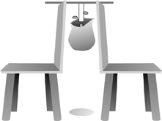
    - Cut a 10.0 cm long piece of tape.
    - Tape 4 cm of the tape to a ziploc bag so that the bag hangs open when you hold the top of the tape.
    - Tape 2 cm of the other end of the tape to the center of the ruler so the bag hangs down.
    - Drop in pennies one at a time until the bag falls.
    - Write number of pennies on data sheet and repeat experiment for each tape.

  - Loop
Steps
    - Cut 25 cm piece of each tape.
    - Make a loop with sticky side out.
    - Attach the middle of the loop to a glass side. The long side of glass slide should align with the width of the tape.
    - Attach abinder clip to the joint of the loop and attach aspring scale to the binder clip.
    - While holding the glass slide in place pull the spring scle upward till the tape is removed from the glass slide.
    - Take a reading on the scale, and write it on your data sheet. Repeat experiment for each tape.

  - Qualitative
Steps
    - Cut 10 cm piece of each tape, and place each one on the table side by side with adhesive side up.
    - Have each member of the group feel each adhesive.
    - Put the tapes in order from most sticky to least sticky.
    - Put results on your data sheet.

  - Rolling Ball
Steps
    - Cut 25 cm piece of each tape.
    - Place each tape on the table from left to right with the adhesive side up.
    - Place the ramp on the right of the tape so the incline faces the tape.Use a ruler to make the ramp and also to guide the marble.
    - Roll the marble down the ramp by releasing and not pushing.
    - Measure the distance from the end of the ramp to the marble.
    - Repeat this step three times on each tape and use an average to get your result. Clean the marble between tests with rubbing alcohol.
    - Put your results on your data sheet.
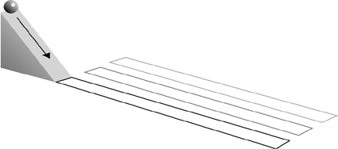
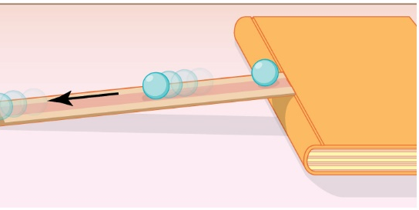

- Shear
Use this test to determine how strong the adhesive is. Use cardboard 1" squares with a hole punched in the center and a staple above and below the hole to prevent tearing of the cardboard.
Steps
  - Cut a 10 cm piece of tape.
  - Attach the 3 cm cardboard square to one end of the tape by putting 2 cm of the tape across the square over the staples and the hole. Repunch the hole.
  - Tape the other end (1 cm) to the side of a tabletop. Place foam rubber or polyurethane under the tape to prevent damage to the floor by the weight.
  - Place a 1 kg weight through the hole in the cardboard, and let it hang.
  - Time how long it takes the weight to fall when the tape releases.
  - Enter the time on your data sheet. Repeat experiment for each tape.
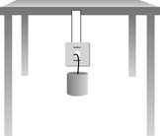

- Peel
Use this test to determine how strong the adhesive is when it is peeled away by force. Various materials may be used such as plastic, cardboard, glass, and wood.

Steps
  - Place 10" strip of tape adhesive side down on the material which is lying on the tabletop.
  - Roll a rolling pin one time over the tape.
  - Repeat this for each tape.
  - Lift each tape off of the tabletop to determine which is stronger.
  - Put the tapes in order from strongest to least strong.
  - Put your results on your data sheet.

Possible Variables tested for Peel
- Pressure on tape. Provide light pressure on one tape and heavy pressure on the other.
- Dwell time. Test one tape immediately and allow the other to stand with the pressure on it for some time before testing.
- Length of tape.(area) Test two tapes of different lengths.
- Nature of surface.
- Angle of peel force. Test at three different angles.
- Reuse of tape. Test a tape and test the same tape again.
- Time adhesive side is exposed to air. Allow tape to stand with the adhesive side exposed to air.
- Water resistance. Allow tapes on surfaces to remain under water for period of time.

- Strength
  - How does the tape resist tear?
  - Tapes can be compared by tearing each and ranking their relative strengths.

- Elasticity
Can the tapes be stretched? Compare the tapes by pulling on them to see if they will stretch without tearing.
Steps
- Cut 5 cm long piece of tape. Attach one end ( 1 cm) to the lab station, hold it on a surface using a finger
- Pull the tape while holding the other end.
- Measure the final length as it tear or you can’t stretch it anymore.

- Adhesive failure
  - Place the tape on a surface.
  - Pull off and estimate the relative amount of adhesive left on the surface.

- Surface Failure
  - Place tapes on cardboard and pull off.
  - Estimate the relative amount of cardboard left on the tape.

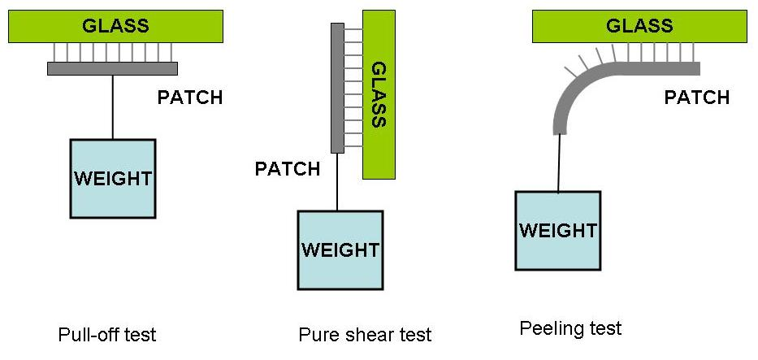http://robotics.eecs.berkeley.edu/~ronf/Gecko/Comparisons/pulloff-shear-peel.jpg

