A Problem of Age

Introduction
This girl was 13 years old in August 2000. Her birthday is in September. How old is she today?
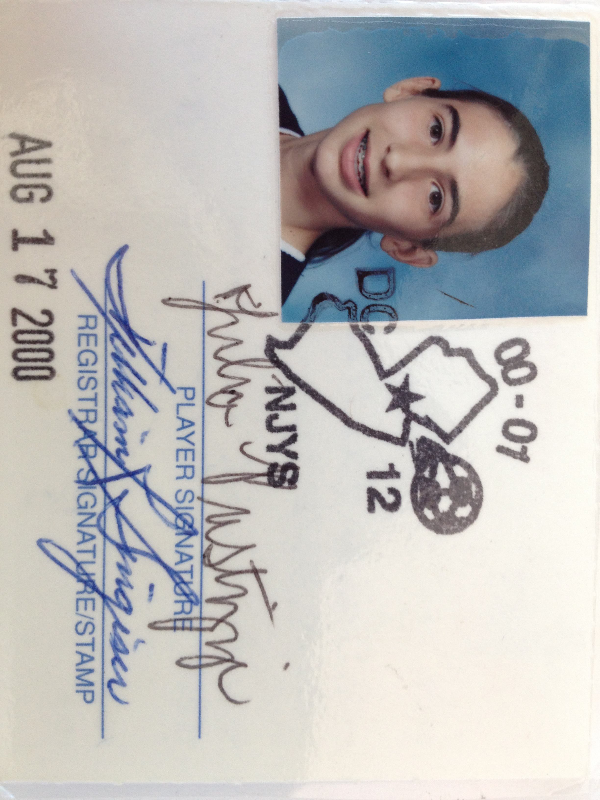

Explanation
In the space below, state this person’s age and explain how you know.

Formalizing Your Claim
To make the strongest argument possible, we will practice a format of explanation called “Claim, Evidence, and Reasoning.” In the space below, you will read the explanation for each of these terms and then write your example based on the problem above.

Claim: the thesis statement or a statement that answers the original question
The girl is …______________________________________________________________ ________________________________________________________________________Evidence: data that supports the author’s claim; must be appropriate and sufficient According to the information given…__________________________________________ ________________________________________________________________________________________________________________________________________________________________________________________________________________________Reasoning: justification that explains how the evidence supports the claim and may incorporate appropriate prior knowledge
Because …_______________________________________________________________ ____________,___________________________________________________________________________________________________________________________________________________________________________________________________________________________________________________________________________________________________________________________________________________________________________________________________________________________________________________________________________________________________________________________________________________________________________________________________________________________________________________________________________________________________________________________________________________________________________________________________________

A Problem of Age

Introduction
This girl was 13 years old in August 2000. Her birthday is in September. How old is she today?

Explanation
In the space below, state this person’s age and explain how you know.

This person is 26 years old. She was 13 before her birthday in 2000, and turned 14 in September of that year. It is now July 2013, 13 years later. She turns 27 this year, but is currently 26.
Formalizing Your Claim
To make the strongest argument possible, we will practice a format of explanation called “Claim, Evidence, and Reasoning.” In the space below, you will read the explanation for each of these terms and then write your example based on the problem above.

Claim: the thesis statement or a statement that answers the original question
The girl is …___26 years old. _______________________________________________ ________________________________________________________________________Evidence: data that supports the author’s claim; must be appropriate and sufficient According to the information given…__she was 13 in August of 2000. Additionally, we know her birthday is in September.___________________________________________
________________________________________________________________________________________________________________________________________________
Reasoning: justification that explains how the evidence supports the claim and may incorporate appropriate prior knowledge
Because …__she was turning 14 in September 2000, we know that she is turning_______
___27 in September 2013 (13 years later). Since it is July 2013, she has not yet turned__
27. Therefore, she must be 26._______________________________________________
________________________________________________________________________________________________________________________________________________________________________________________________________________________________________________________________________________________________________________________________________________________________________________________________________________________________________________________________________________________________________________________________________________________________________________________________________________________________________________________________________

Krajcik and McNeill. Assessing Middle School Students’ Content Knowledge and Scientific Reasoning Through Written Explanations. 4-5.
Krajcik and McNeill. Assessing Middle School Students’ Content Knowledge and Scientific Reasoning Through Written Explanations. 4-5.

