Evaporation rates
In this laboratory experiment you will predict and measure the cooling effect of different liquids. Your knowledge of Lewis structures, VSEPR theory, molecular geometry and intermolecular forces will allow you to rate the polarity of the liquids. The type of IMF, along with molar mass, will allow you to predict the relative cooling effect of the different liquids. Then you will test your prediction by measuring a temperature drop during evaporation.
Pre-lab
For each of the liquids in the table below, draw the structure. Determine the molar mass and indicate whether the molecule is polar or nonpolar and state the type of intermolecular forces that are present.

Liquid | Formula | Molar mass | Lewis structure | Polar/non polar | IMF Type
Methanol
Ethanol
n-Propanol
n-butanol
n-pentane

Underneath the liquid name, indicate the order of rate of evaporation that you expect (1 = fastest and 11 = slowest) and the dipole moment (D)
Materials
Filter paper cut into 2.5 x 2.5 cm pieces, Vernier temperature probe, interface, Logger Pro and computer or Digital thermometer and stopwatch or glass thermometer and stopwatch Small rubber bands (tubing cut in thin sections) Masking tape Test tubes with stoppers Test tube holder
Part A - Effect of Molar Mass - Liquids: methanol, ethanol, n-propanol, n-butanol
Part B – Effect of Molar Mass – Liquids: pentane, hexane, heptane, octane
Part C – Effect of Number of Hydrogen Bonds – Liquids: glycerin, water, methanol, hexane
Part D – Effect of Type of Intermolecular Force – Liquids: water, n-propanol, acetone, hexanes
Safety Caution!
The liquids used in this experiment are flammable. There should be no open flames or sources of sparks near the liquids. Avoid inhaling the vapors or contact with your skin or clothing. Let your teacher know immediately if a spill or accident occurs. Obtain and wear safety glasses and lab aprons.
Procedure
Your teacher will assign the parts of this experiment that you will be doing. If you will not be doing all parts, then the data obtained from each group will be shared. The procedure for each liquid of each part is identical and is given below. With care, two liquids can be done at once.
- Obtain stoppered test tubes containing about 3 mL each of the liquids that you will measure. Make sure that they are marked so that you can identify them.
- Obtain as many pieces of 2.5 cm x 2.5 cm filter paper as liquids that you will test.
- Obtain or cut 2 small rubber bands and 2 pieces of masking tape.
- Secure the filter paper to the probe or thermometer. Make sure to only cover the top portion of the filter paper so as to allow for evaporation.
- Place the wrapped probe or thermometer in the test tube with the liquid. After one minute record the initial temperature as the “time zero” temperature in the data table.
- Quickly remove the probe or thermometer and place it on the lab bench so that the filter paper end hangs over the edge. Secure in place with the masking tape. 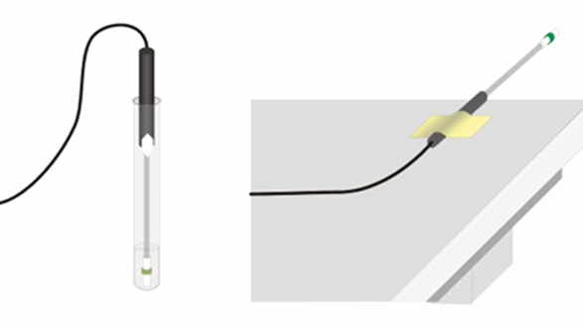
- Record the temperature every 10 seconds until the temperature reaches a minimum and then begins to increase again or for 5 minutes, whichever comes first. Make sure to avoid breezes and do not blow on the filter paper to make it evaporate faster.
- Repeat this process with the next liquid.
- Clean up by adding the waste to appropriate container and make sure to close the lid. This must be done in the hood so please do not remove the containers out of the hood.
- Obtain and share data with your classmates as directed by your teacher.
Data Table
Table 1: Change in temperature for “A” group liquids
Time (s) | Methanol | Ethanol | Propanol | Butanol

Table 2: Change in temperature for “B” group liquids
Time (s) | Pentane | Hexane | Heptane | Octane
Table 3: Change in temperature for “C” group liquids
Time (s) | Glycerin | Water | Propanol | Hexane

Table 4: Change in temperature for “D” group liquids
Time (s) | Acetone | Water | Propanol | Hexane

Table 5: Comparison of change in temperature of all the liquids used based on molar mass.
Liquid | Change in Temperature | Molar mass
Methanol (A,C)
Ethanol (A)
Propanol (A,D)
Butanol (A)
Pentane(B)
Hexane (B,C,D)
Heptane (B)
Glycerin(C)
Water (C,D)
Acetone (D)

Data Analysis
- Make a graph of temperature change vs. molar mass for the “A” solvents. Connect the data points with a smooth curve. To the graph add the “B” solvents. Make sure to include a key with your graph. (This is done most easily using Excel.)
- Make a graph of the change in temperature vs. the number of hydrogen bonds for the “C” solvents.
Conclusion Questions
- How did molar mass affect the rate of evaporation? Use the graph for group A and group B. Remember a small temperature difference indicates a slow rate of evaporation.
- From the graph of liquids “C” what can you conclude about the number of hydrogen bonds and the rate of evaporation?
- What is the main difference between liquids “A” and liquids “B”?
- For liquids “D” was the most polar solvent the one with the slowest evaporation rate? Was the least polar compound the one with the fastest evaporation rate? Explain your answer. Include discussion of the dipole moments obtained from WebMO and the type of intermolecular forces.
- Based on your data, what do you think has a greater effect – molar mass or type of intermolecular force? Explain and justify your answer.
- Did the order of evaporation rate that you indicated in the pre-lab exercise, correspond with your results? Please indicate any differences and offer an explanation for the discrepancy.
- What are some sources of error in this lab?

