Teacher Background
Properties of Soil
We generally don’t think much about soil. In fact, “soil” can have a negative connotation. We call it dirt and wash it off our clothes and our bodies. In reality, the soil is essential to our survival and that of nearly every organism on Earth. Our planet is mostly made of rock with an iron-nickel core. Plants and animals, including us, occupy a thin veneer on its surface. Our existence is possible because of a thin layer of soil that comes between the planet’s rocky interior and us.
The weathering of rock slowly produces soils. Constant exposure to wind and rain cause the rocky crust to slowly break down into smaller particles. It can take centuries to produce fertile topsoil. As rainwater seeps into cracks, temperature extremes cause the water to freeze. The rock expands, contracts, and fractures. These weathering actions are helped along by organisms that live on and in the soil. Soils are composed of inorganic material derived from rock and organic material derived from living and dead organisms. Both are important to support plant growth. Some scientists believe that without life, soils are just dirt.
As weathering breaks down inorganic material, particles of various sizes are produced. Soil texture refers to the relative proportions of different-sized particles found in the soil. Scientists classify soil particles into three categories. The smallest particles, which measure less than 0.002 millimeters, are called clay.¹⁶ Clay is important in holding nutrients. Clay particles form plate like structures that act like magnets, holding nutrients until they are displaced by another element, absorbed by a plant root, eaten by a soil microbe, or chemically absorbed into the soil. The next largest particles are called silt. Silt particles range in size from 0.002 millimeters to 0.06 millimeters. Sand refers to the largest particles. Sand grains range in size from 0.06 millimeters to 2 millimeters. Soils vary in their proportions of clay, silt, and sand. Soil scientists classify different soil types using the soil triangle. Each side of the soil triangle represents the amount of a soil component, clay, silt, or sand. The relative amounts of these three particle sizes intersect within the triangle and determine to what type of soil those proportions correspond.

Figure 1. The soil triangle is used to classify soil types.
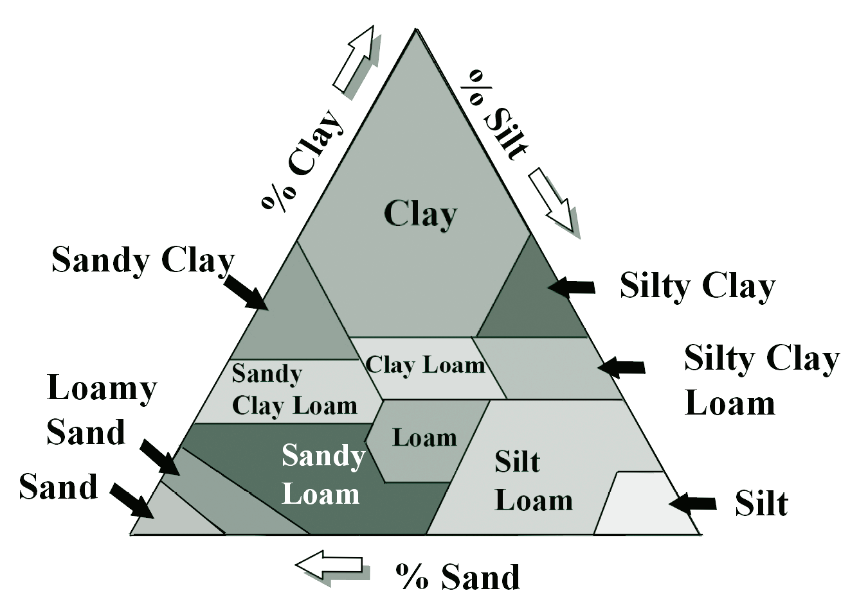

The ability of a soil to accept and retain water is largely determined by the relative amounts of clay, silt, and sand present. Porosity refers to spaces in the soil that can hold either air or water. Permeability is defined as the rate at which water can travel through soil. Table 8 lists properties of particle size that relate to soils’ interactions with water. Soils with desirable properties for farming are called loams. Loamy soils typically contain about 50 percent air space, which allows root systems to “breathe” (i.e. obtain O₂ for respiration). The solid half of soils is about 90 percent minerals and 10 percent organic material. Usually, loamy soils have names that more accurately reflect their composition, such as clay loam or silt loam.

Properties of Soil Particles
Property | Clay | Silt | Sand
Porosity | Mostly small pores | Mostly small pores | Mostly large pores
Permeability | Slow | Slow to moderate | Rapid
Water-holding capacity | Large | Moderate | Limited

Although the organic fraction of most soils is small in volume compared to the mineral fraction, it plays an important role in supporting plant growth. The organic material is composed of living organisms, plant roots, and plant and animal residue. A single gram of healthy topsoil may contain 100 nematodes (small roundworms), 1 million fungi, and 1 billion bacteria.²⁴ Present in smaller numbers may be earthworms and a wide variety of insects. Organic material contains a significant amount of nutrients and it, together with plant roots, helps:
- Decrease erosion
- Increase water infiltration and storage
- Act as a pH buffer (to maintain an acid-base balance)
- Decompose organic material, releasing nutrients
- Recycle carbon, nitrogen, and other nutrients
- Retain available nutrients such as metal ions.

The soil is a “bank” for nutrients that are taken up by plants, and these nutrients must be replenished for continued plant growth. Before the advent of modern agriculture, farmers relied solely upon tillage to break down existing organic material and release existing soil nutrients. This practice is still used in many less developed countries.

