Activity #3 Weathering and Surface Area

Objectives:
- To understand the importance of surface area when it comes to weathering of rocks and minerals.
- To learn how to design your own independent experiment.

Background: There are two types of weathering; mechanical and chemical. Mechanical, or physical, weathering is the breakdown of rocks or minerals into smaller pieces, while chemical weathering breaks a rock or mineral down by altering a rock or mineral’s chemical composition.
Weathering can be affected by several forces, including exposure, particle size, mineral composition, and climate. This activity will look at the role of particle size and how fast a material can be weathered.

By breaking a rock into smaller pieces, mechanical weathering increases the rock’s surface area that can be exposed to chemical weathering.

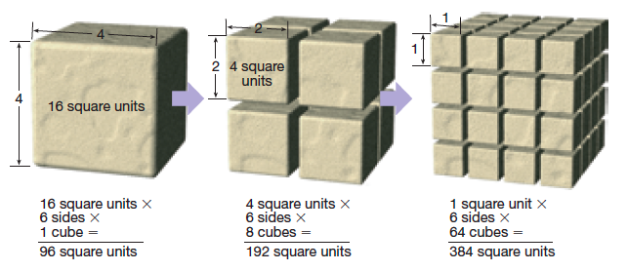

List of materials:
• Acid solution (dilute vinegar)
• SweeTARTS TM (the same color)
• Hammer
• Stop watch
• Clear cups or beakers
• Safety goggles (if stronger acid)

Procedure:
1. Break into groups of 3 or 4.
2. Develop a question based on your previous knowledge of weathering of rocks and minerals and the figure above.
3. Turn that question into a hypothesis.
4. Design an experiment that could test that hypothesis with the materials provided to you.
5. Carry out your experiment.
6. Determine if your hypothesis was correct.
7. Answer follow-up questions.

Planning your Experiment:

What is your question about weathering of rocks and minerals?

What is your hypothesis?

Methods: Explain how you will test your hypothesis.

What are your independent and dependent variables?

What will you be keeping constant during your experiment?

Provide a sketch of your set-up.

Observations: Record what happens. Provide any measurements in a table.

Results/Conclusion:

Was your hypothesis correct? Explain.

Follow-up questions
1) Based on the results of your experiment, predict which of these would weather the fastest - a smooth round pebble or a jagged piece of rock. Why?

2) Explain how water could be a form of both mechanical and chemical weathering.

Activity 3. Weathering and Surface Area
KEY

Teacher Tips:
Note, in using SweeTARTS TM in the weathering activity, it was found helpful if they used the same colored candy for each treatment. It was found out that a good way to measure how much the SweeTARTS TM had dissolved was by looking at the color of the water that resulted. Also it is important to note that the candy will not dissolve completely, so one of the independent variables should be a set time. Between 5 and 10 minutes was found to be appropriate enough to determine their results.

Materials:
- Acid solution (dilute vinegar)
- SweeTARTS TM (the same color for each group)
- Hammers
- Stop watch (students can use their phones)
- Clear cups or beakers
- Safety goggles (if stronger acid)

Procedure:
1. Break students into groups of 3 or 4.
2. Students may need guidance to develop a question based on previous knowledge of weathering of rocks. This activity is designed to follow a unit on rocks and minerals. Prentice Hall Earth Science (2006) references rocks and minerals in chapters 2 and 3
3. Turn that question into a hypothesis. A good hypothesis could be an If-Then statement. It’s ok if students don’t actually prove their hypothesis correct!
4. Design an experiment that could test that hypothesis with the materials provided to you.
5. Carry out your experiment.
6. Determine if your hypothesis was correct
7. Answer follow-up questions

Possible Answers below in italics

Question:
Which dissolves faster – a solid SweeTARTS TM or a SweeTARTS TM that is broken up into smaller pieces?
What is your hypothesis?
If the particle size is smaller (more surface area), then the candy will dissolve (weather) faster.

Methods: Explain how you will test your hypothesis. What are your controls? What are your independent and dependent variables? Provide a sketch of your set-up.
We will have two cups of acid – CONTROL
A whole piece of candy will be put into one cup and a piece of candy smashed with a hammer will be put in the other – INDEPENDENT VARIABLE
They will both stay in the acid for 10 minutes – CONTROL
After 10 minutes, will we examine the amount of candy left and the color of the water to determine which “weathered” faster – DEPENDENT VARIABLE

Observations: Record what happens. Provide any measurements in a table.
The smaller particle size (the broken candy) dissolved faster.

Results/Conclusion: Was your hypothesis correct? Explain.
Yes – the SweeTARTS TM that was broken up into smaller pieces dissolved the most

Follow-up questions
1) Based on the results of your experiment, predict which of these would weather the fastest - a smooth round pebble or a jagged piece of rock. Why?
The jagged piece of rock has more surface area and can be weathered faster.

2) Explain how water could be a form of both mechanical and chemical weathering.
Water can continually wash over rock, breaking it down over time like waves hitting the shore (physical), or water can be acidic and dissolve particles like limestone chemically.

