Objectives:
You will be setting up an experiment to measure how much of an effect stream velocity has on erosion and deposition of sediments.
You will practice the steps of how to conduct an experiment.

Background: In activity 1, you witnessed several processes and formations that are the result of stream transportation of sediment. Sediment is eroded (moved) from the top of a watershed by a stream and its tributaries. That sediment is then deposited at the mouth of the stream, located in the bottom portion of a watershed. The amount of erosion and deposition that occurs can be determined by measuring how large a stream’s delta grows over time. This process is dependent upon the velocity of the stream. Velocity is the speed of the water in the stream, usually measured in meters per second. Another key is the amount of water, or discharge involved.

Sediments Removed Sediments Deposited
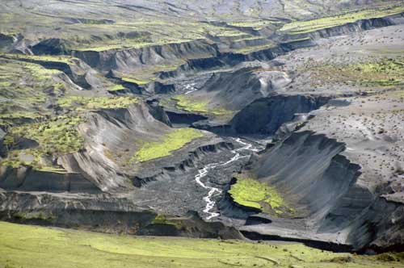
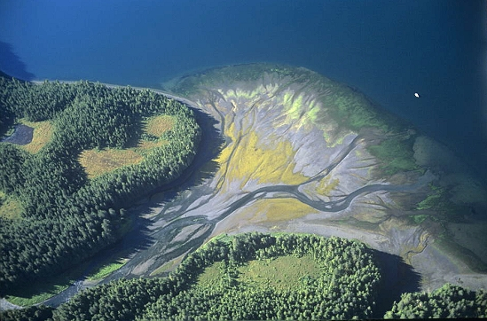

List of possible materials:
- Stream table
- Stopwatch
- Plastic gutter
- A ruler or other tool
- Pencil
- Calculator
- Plexiglas sheet
- 250ml beaker
- Dry sand
- Plastic shovel/scooper

Procedure:
1. Examine the Question found below and develop a hypothesis from it. What will happen to the sediment in your streambed as you increase/decrease the velocity of the water?

2. Under Methods, design an experiment that could test your hypothesis. Your design should include at least the following:
- Conduct at least three trials with the same stream shape each time at a slow, medium and fast flow (velocity!)
- Conduct each trial for the same amount of time (Why?!)
- Measure the “volume” of the delta after each trial in cubic centimeters (length x width x height)
- Record your data in your science notebook.
3. Construct your defined stream on the stream table (straight and narrow works well) Be sure to set up the experiment exactly the same for each trial to eliminate variables.

4. Assign the needed roles in your group (these should stay the same through the whole experiment to keep data collection consistent), you may have more than one role!:
- Flow director
- Time keepers
- Delta measurer
- Data recorder
- Engineer to keep the same stream size and shape and to redistribute the sediments

5. Carry out the experiment that you designed under the Methods section.

6. Determine if your hypothesis was correct.

7. Answer follow-up questions.

Question: How does the velocity of a stream affect how much erosion and ultimately deposition will occur?

What is your hypothesis?

Methods:
Explain how you will test your hypothesis.

What are your independent and dependent variables?

What will remain constant in your experiment?

Observations: Record what happens. Provide any measurements in a table. Use a separate sheet of paper if needed.

Results/Conclusion:

Was your hypothesis correct? Explain.

Follow-up questions
1) What do you think would happen if we increased or decreased this stream’s slope (make it steeper or flatter) instead of increasing the flow of water?

2) What events in nature did rate of flow represent in this experiment? Hint: Think about weather and climate.

3) How do people try to control rivers and streams in “real life?” How would engineers keep a real stream from changing its size or course?

